 Wb: 18.10.21
 |  | Break |  | Break |  | Lunch |  |  | Home time
Mon | RWI  https://www.youtube.com/watch?v=p7hRbrpq5Bo&t=25s |  | Maths  Fact families  https://vimeo.com/465032733 |  | English  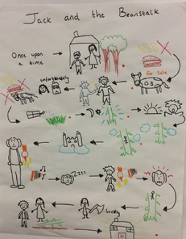  Story map Jack and the Beanstalk. Verbally rehearse telling the story. |  | Games  https://www.youtube.com/user/cosmickidsyoga | Assembly
Tues | RWI  https://www.youtube.com/watch?v=p7hRbrpq5Bo&t=25s |  | BOLE |  | Maths  Number bonds to 10  https://vimeo.com/463891935 |  | Art  Colour - Colour - National 5 Art and Design Revision - BBC Bitesize  Look at the PowerPoint or Video Link to learn about making tints and shades by adding white and black to a colour.  Use the template to make your own tints and shades. | Assembly | Look
Weds | RWI  https://www.youtube.com/watch?v=p7hRbrpq5Bo&t=25s |  | Maths  Systematic number bonds  https://vimeo.com/463893092 |  | English  Write the story of Jack and the Beanstalk. Focus on capital letters, full stops and finger spaces. There is a word mat below to help. |  | 1LS  Free Flow  Autumn themed (leaf rubbing)  1BC  PE  https://www.youtube.com/user/cosmickidsyoga | Assembly
Thurs | RWI  https://www.youtube.com/watch?v=p7hRbrpq5Bo&t=25s |  | Maths  Number bonds to 10  https://vimeo.com/463894279 |  | Black History  Look at the PowerPoint to learn about Rosa Parks and how she stood up to unfair treatment.  Create a placard to remind people that it’s important to treat other people fairly. |  | 1BC  Free flow  Autumn themed (leaf rubbing)  1LS  PE  https://www.youtube.com/user/cosmickidsyoga | Assembly

