 Wb: 28.02.22
 | Register 9:15  9:20-10:20 |  | 10:35-11:20 |  | 11:35- 12:30 |  | 1:20 |  | 3:15
Mon | RWI  https://www.youtube.com/watch?v=p7hRbrpq5Bo&t=25s | Break | Maths  Compare lengths  https://vimeo.com/507433257  Find 3 things longer than your pencil.  Find 3 things shorter than your pencil.  How should you compare them? | Break | DT Lesson 1  Ppt looking at houses before and after the Great Fire of London.  Design and label a new house for someone who lost their home in the Great Fire. Label each part of the house and what materials have been used.  (Video on class page) | Lunch | Games  https://www.youtube.com/user/cosmickidsyoga |  | Home time
Tues | RWI  https://www.youtube.com/watch?v=p7hRbrpq5Bo&t=25s |  | Maths  Compare heights  https://vimeo.com/507433540  Can you put yourself in height order with the people on your table? Who is taller than you? Who is shorter than you? |  | DT Lesson 2  Tell chn that today they are going to use the two boxes they brought in to make a two-story house.  Part 1  Use glue to stick the two boxes together and masking tape to secure the two boxes together to help strengthen the structure of the building.  Part 2  Cover the house in bits of white paper using glue. Explain that this will help strengthen the structure and also ready it for painting next lesson.  (Video on class page) |  | Handwriting  Maths minute  Reading  https://www.topmarks.co.uk/maths-games/5-7-years/addition-and-subtraction | BOLE/Maths  Compare lengths & heights  https://vimeo.com/507943851  Can you find something taller and shorter than you? | Home time
Weds | RWI  https://www.youtube.com/watch?v=p7hRbrpq5Bo&t=25s |  | Maths  Measuring lengths (non-standard units)  https://vimeo.com/507969952  Can you use cubes to measure items on your table? |  | Measure length (1)  https://vimeo.com/508439670  Use hands/sticks/cubes to measure items outside. |  | 1BC  PE  https://www.youtube.com/user/cosmickidsyoga  Music  1LS  BOLE/DT/Fire of London  PPT slides about Sir Christopher Wren(architect in charge of rebuilding after the fire.  Children to practise using tools (wood, hand drills, hammers and nails)  Skills that would have been needed to help build the new houses. |  | Home time
Thurs | RWI  https://www.youtube.com/watch?v=p7hRbrpq5Bo&t=25s |  | DT Lesson 3  Chn to draw detail onto their houses e.g windows, beams on house to make them look simular to pictures of houses we looked at in lesson 1.  Chn to then paint houses.  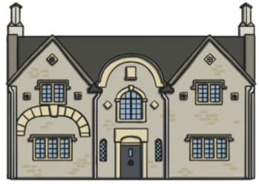  (Video on class page) |  | DT Lesson 4  Children to evaluate their design using the template given.  (Video and template on class page) |  | 1LS  PE  https://www.youtube.com/user/cosmickidsyoga  Music  1BC  BOLE/DT/Fire of London  PPT slides about Sir Christopher Wren(architect in charge of rebuilding after the fire.  Children to practise using tools (wood, hand drills, hammers and nails)  Skills that would have been needed to help build the new houses. |  | Home time
Friday | RWI  https://www.youtube.com/watch?v=p7hRbrpq5Bo&t=25s |  | DT Lesson 5  Use template to create a lever to look like the fire is spreading across a row of houses. Children to cut out pieces. Stick flames to the lever. Cut along the two red lines and slide the fire along the houses. |  | RE  Read Easter story from the Bible. https://www.youtube.com/watch?v=RdFwU4WJ_84  What parts make you feel happy? Sad?  Show a colour chart, what are the happy colours? What are the sad colours?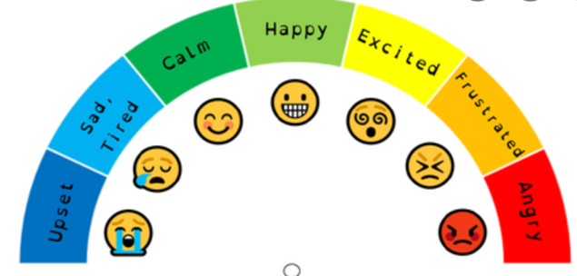  Children to colour in two crosses.  One in happy colours and one in sad colours.  Stick pictures from the Easter story to the different crosses. Which parts make you feel happy? Which make you feel sad? |  | PSHE |  | Home time

