L.O: To investigate patterns Wb: 04.10.21
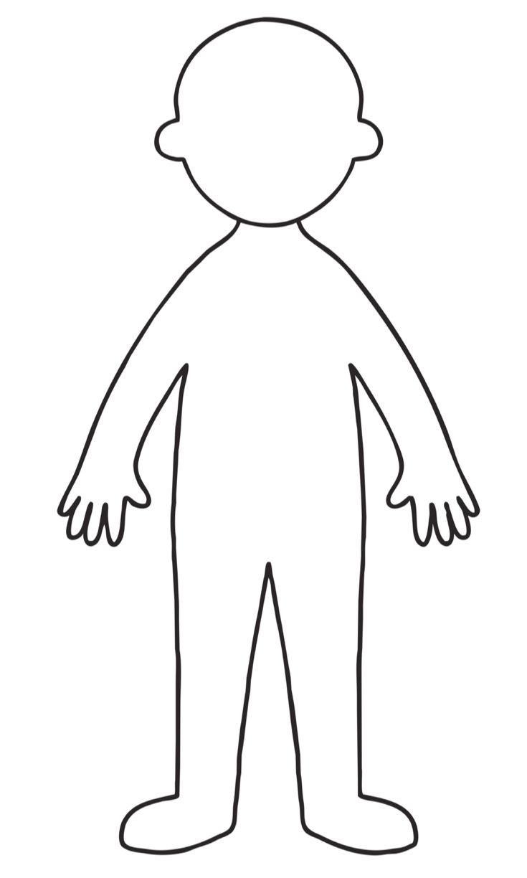
C: Weather

