L.O: To organise writing appropriately wb:14.03.22
C: Recount

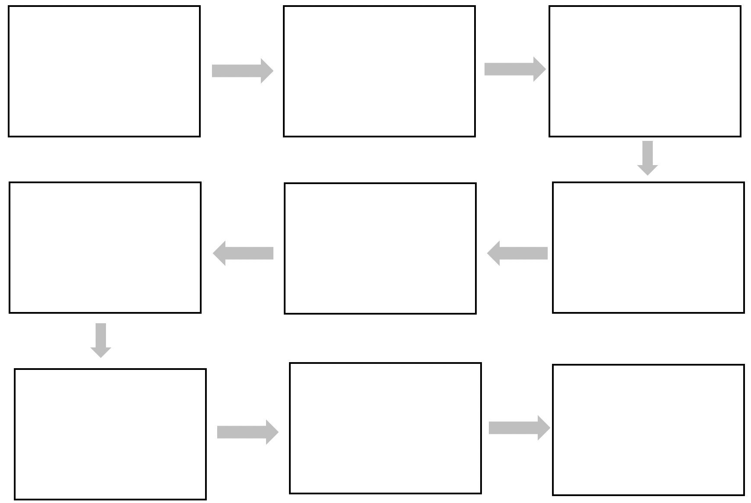
Creating our post Fire of London Houses

