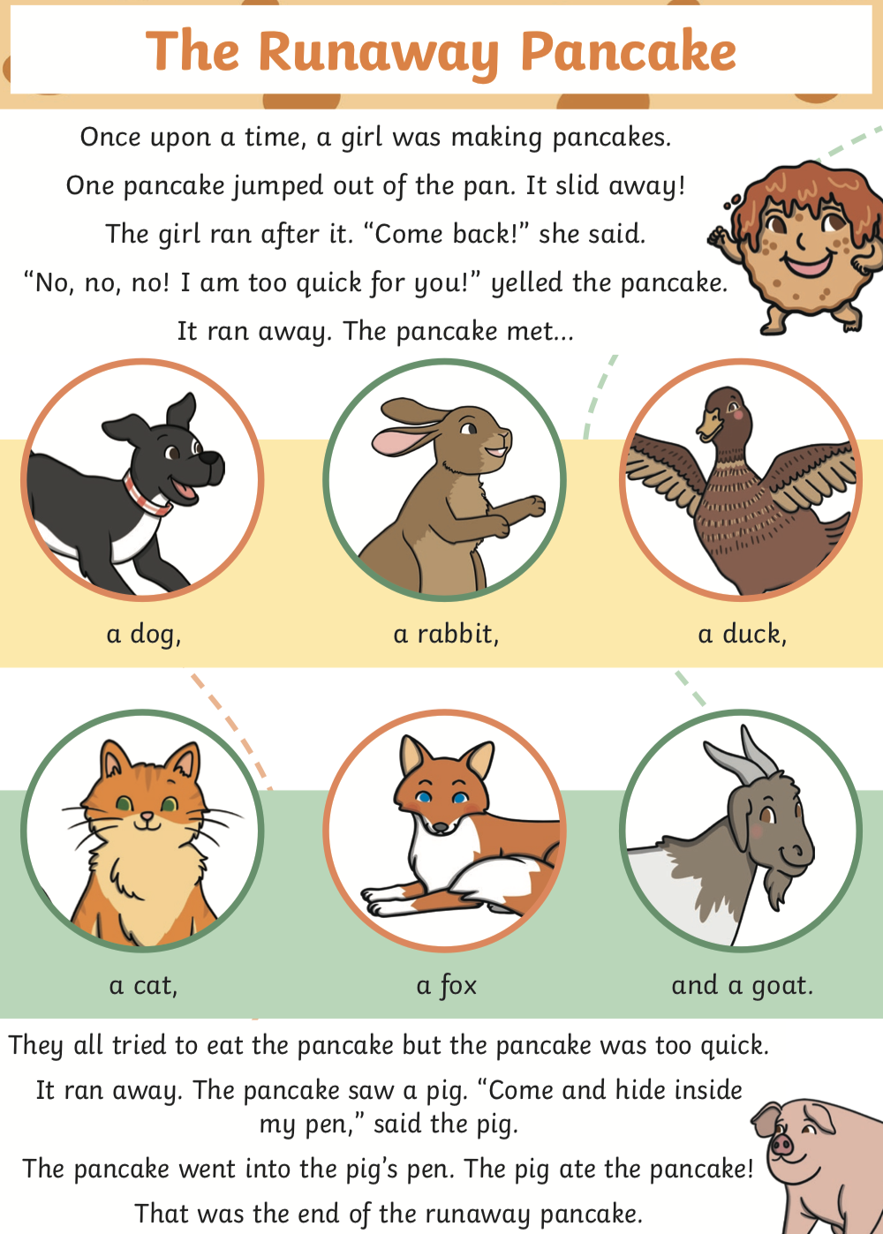

L.O: To answer questions about a text Wb:07.03.22
C: The Runaway Pancake

- Who was making pancakes? Tick one
- a pig
- a pancake
- a girl

- What did the girl say? Tick one.
- “Come back !”
- “No, no, no!”
- “Come and hide inside my pen”

- Draw line to complete each sentence.

They all tried to eat the pancake |  | into the pig’s pen.
The pancake went |  | but the pancake was too quick.
The pig |  | ate the pancake

- Where did the pig want the pancake to hide?

__________________________________________________

- What do you think the girl will say when she finds out what has happened to the pancake?

__________________________________________________

__________________________________________________

