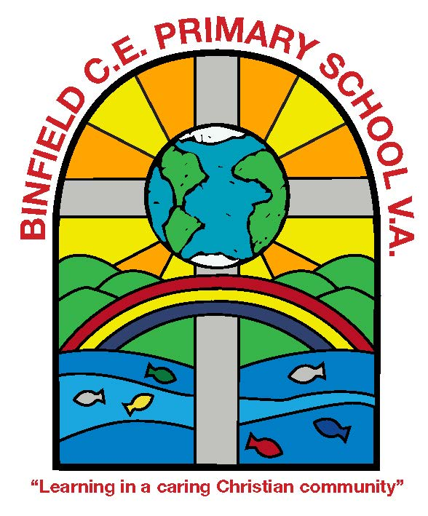
Books for Year 5
At Binfield School, we love reading! Good writers are also good readers and it is really important that children read widely to expose them to different story plots and ways of writing sentences, as well as to extend their vocabulary. The following recommendations represent a range of genres which we hope will ignite, re-kindle or fan the flames of your child’s desire to read. We have chosen texts which may be less familiar, from authors with a track record in writing high-quality children’s books. We hope amongst this selection, there will be a book or an author that becomes a family favourite for your child. Remember age is no barrier to exploring books on other book lists as well.

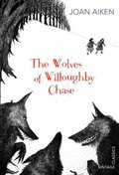

The Wolves of Willoughby Chase
by Joan Aiken

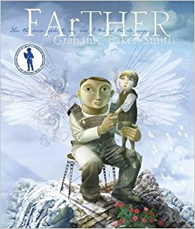
FArTHER
By Graeme Baker-Smith

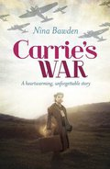

Carrie's War
by Nina Bawden

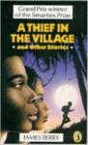

A Thief in the Village
By James Berry
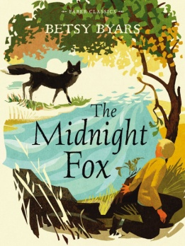
The Midnight Fox
By Betsy Byars

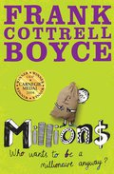

Millions
by Frank Cottrell Boyce

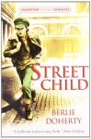

Street Child
By Berlie Doherty
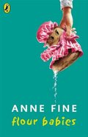

Flour Babies
By Anne Fine

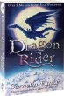

Dragon Rider

by Cornelia Funke

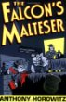

The Falcon’s Malteser

By Anthony Horowitz
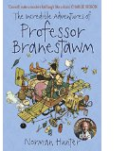

The Incredible Adventures of Professor Branestawm
By Norman Hunter
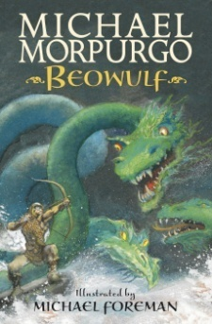
Beowulf
By Michael Morpurgo
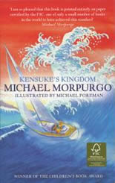
Kensuke’s Kingdom
By Michael Morpurgo

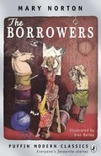

The Borrowers
by Mary Norton

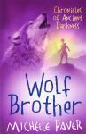

Wolf Brother
By Michelle Paver

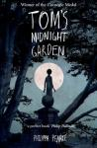

Tom's Midnight Garden
By Philippa Pearce

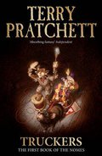

Truckers
by Terry Pratchett

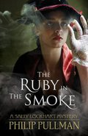

The Ruby in the Smoke
by Philip Pullman

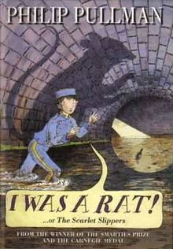

I Was A Rat
by Philip Pullman

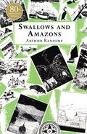

Swallows and Amazons
by Arthur Ransome

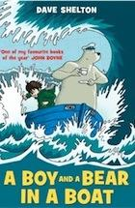

A Boy and a Bear in a Boat
By Dave Shelton
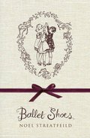

Ballet Shoes
by Noel Streatfeild

