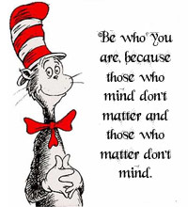
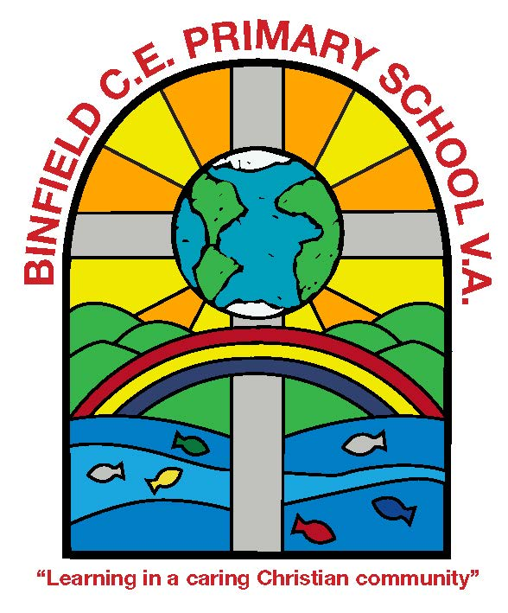
Reading At Home
A Booklet for Parents

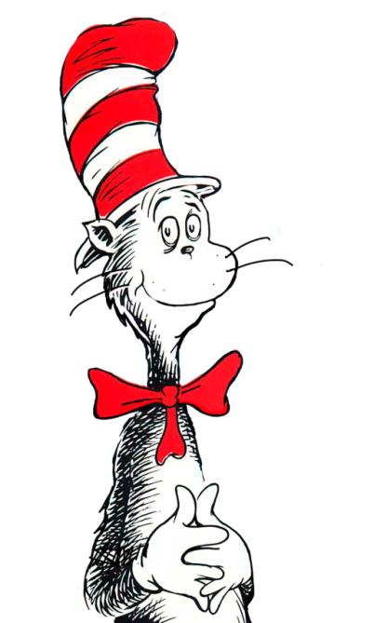
“The more that you read, the more things you will know. The more that you learn, the more places you’ll go.”
Dr Seuss

One of the greatest gifts that you can give your child is to read with them from an early age. You don’t have to be an expert. There’s no magic in supporting children’s reading, just patience, time and affection, plus a little skill.

It’s important to remember that learning to read is not a race! For some children, learning to read will seem to happen easily and quickly. For others, more time and support will be needed. If you have any questions or concerns about your child’s reading, please come in and talk to your child’s class teacher.

The first part of this booklet has ideas for how to make reading time fun and enjoyable. The second part has suggestions for book titles that you may like to try with your child.

Is reading just about knowing what words say?

Being able to read the words on a page is important, but so is understanding.

A good reader:
· Understands what they have read.
· Can summarise what they have read.
· Can read aloud with expression.
· Can choose what they’d like to read for themselves.
· Is able to talk about what they like to read.
· Can explain their views on what they have read.
How can I help my child to enjoy reading?

- Make it a ‘special’ time:

· No distractions (e.g. TV).
· Rewards and challenges
· Use humour at difficult moments.
· Aim to have a ‘reading routine’, perhaps at the same time every day.
· A little reading goes a long way! Just fifteen minutes a day can make a big difference to your child’s reading ability.

- Plenty of praise and encouragement.
· Say how much you enjoy listening to them read!
· Make sure that children know that you are happy as long as they are trying their best.
· Be an ‘actor’! If it’s a frightening book, look scared. If it’s funny, then laugh. If it’s a mystery book, look puzzled.
· Try to encourage enjoyment and fluency without concentrating too much on errors.
· Always end on a ‘high note’.

- Be seen reading!
· Seeing you read will inspire your child to read too!

- Give your child a wide array of reading material.
e.g. magazines, newspapers, comics and fiction books.
· Put these in cars, bathrooms, bedrooms, family rooms, and even by the TV.
· Take trips to the library every few weeks to choose new books.

- It is OK to read the same book several times!
If your child enjoys a book, it is great to let them read it again as they will be more likely to remember great words and ideas (as well as spotting things they missed the first time they read it!).
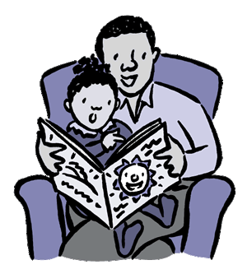

How do I help my child to choose a new book?

- Go for what they’re interested in!
Sports? Music? Dinosaurs? Choose books that relate to an interest your child has. Your child won’t want to read the book otherwise!

- Don’t just encourage your child to read fiction books (story books)
It is important that your child reads other types of writing from ’real life’ as well, for example newspapers, recipes, encyclopaedias and adverts. Some children prefer non- fiction books, although they should also be encouraged to read fiction.

- If your child has to stop a number of times in a sentence to work out what words say, the book may be too difficult for them.
However, don’t discount the book completely—you can always read it to them!

- Always go for interest and enjoyment over level.
You can always read the book to them if they get stuck!

- If they genuinely do not enjoy the book, change it.
There is no need to labour to the end! Discuss why they didn’t enjoy the book.

How do I introduce a new book?

- Start with the title and look at the cover. What might the book be about?

- Go through words they might find tricky in the book to boost their confidence.

- At the bottom of each page, encourage your child to predict what will happen next.
What happens if my child makes a mistake?
What should I do if my child makes a mistake when reading to me?

If what he or she reads still makes sense:
· Let him / her continue on until there is a sensible break (e.g. end of sentence, paragraph or page).
· Say something like, “You read that really well and it made sense, but let’s look at that word again. You said ***. Check it again.”

If it made no sense:
· Stop.
· Say: “You’re doing well, but that doesn’t make sense. What sort of clues will help us work out the word?”
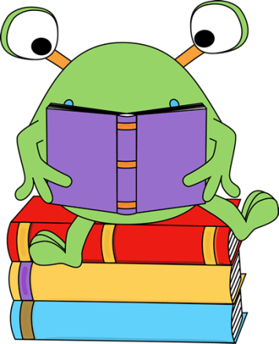

What shall I do if my child gets stuck on a word?

· Break down the word into chunks (syllables) – chimp-an-zee
· Read to the end of the sentence: this way, they will not lose the flow of what they are reading. Then, go back and look at the word again.
· Think about other words which look similar.
· Use illustrations as clues.
· Explain what the word means.
· After a reading session, go back to the tricky word. Can your child remember what the word said?
· In some cases, it may be necessary to tell your child the word so that they don’t lose the flow of what they are reading.
Can I read to my child?

Yes! Reading aloud to children is important, no matter their age!
Listening to a story allows children to concentrate on the ‘message’ rather than purely what the words ‘say’.

‘Shadow read’ – sometimes you could read quietly alongside your child, so that if they stumble over a word, they can fall back on you.

We seem to spend more time battling over what the words say. Reading has stopped being fun!

Check with your child’s teacher. They will be able to tell you if the book is a little hard for them.

It is important that children ’hear’ stories being read to them as well.
This could be you reading to them, or listening to a story CD. You can then discuss what you have heard.

Picture books
Picture books aren’t just for early readers! These can be useful to discuss how a character is feeling. Look for clues in the picture that tell you how the character is feeling.

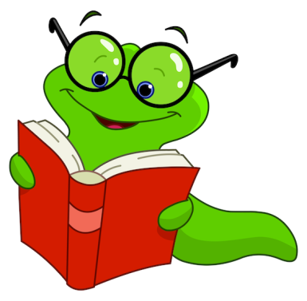

When I ask my child about what they have read, they use the illustrations to help them. Should I cover up the illustration?

Looking at pictures can help enrich a child’s understanding of a book. Rather than cover up the illustrations, use them to discuss what they think will happen next.
What if my friend’s child seems to be reading a harder book than mine?

Learning to read is not a competition!
For some children, learning to read will happen quickly and easily, but for others, it will take more time. Books on the reading scheme help us to select reading material that is roughly appropriate to your child’s reading ability, but the levels are only a guide. ‘Racing’ through book levels to get to the next can take the enjoyment out of reading. Feel free to read other books outside of the reading scheme at home with your child as well!

It’s not a race!
Remember...
If you’re not sure, ask your child’s teacher.

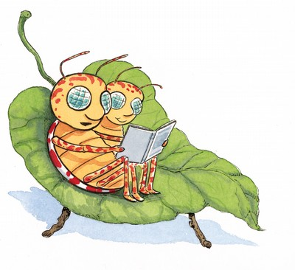
Give your child time to think about an answer.
It’s not a test! If your child gets stuck, you can help!
Reading should be fun!

Give your child lots of praise for trying hard.

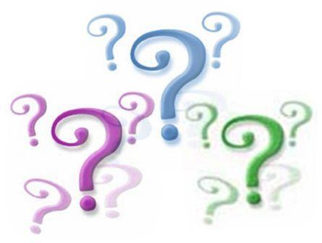
Reading Questions

The following questions can be used as a starting point for discussing what your child has read. They are suggestions - don’t feel that you have to stick to just these questions, or get through them all! It is important that your child can explain their answer. You could ask the question “Why do you think this?” or “How do you know?”

Characters

What can you tell me about the characters?
Do you agree with what they did?
How would you feel towards this person / character if you met them in real life?
What words have been used to describe ***?
Why do you think the author chose to describe them in this way?

Beginning a new book

What made you choose this book?
What can you tell me about this story from the title / illustration / blurb?
Who is in this story?
What is this story / book about?
Where is it set?

Setting

When was this story set?
Where does this story take place?
What can you tell me about the setting?
What is the atmosphere of this writing?
What words have been used to make a spooky / calm / frightening atmosphere?

Plot

Put into your own words what has just happened.
What do you think will happen next? Why?
What would you like to happen next? Why?

Evaluation

Did you enjoy this story / text?
What was the best bit?
Why do you think the author ended the story in this way?
Have you read any stories similar to this?
What sort of person would you recommend this to?



