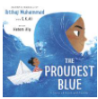



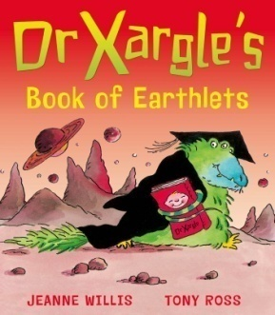

Dr Xargle’s Book of Earthlets
By Levi Pinfold

The Proudest Blue
By Ibtihaj Muhammad
Children need to learn to read a variety of texts and poems are one of those forms. The unique thing about poetry is that we often read aloud, repeat often, and share in groups. When children are listening to poems orally, they are building their listening skills. They learn to attend to the words they hear and to think about what those words mean together.
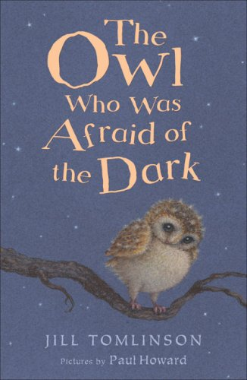

The Owl Who was Afraid of the Dark
By Jill Tomlinson

In Guided Reading we share books and discuss themes. We also use them to develop our children’s writing and comprehension skills.
At Binfield Primary School we love reading! This list comprises of a range of genres ranging from poetry, contemporary and diverse authors. We are a big fan of the classics as well. We want to inspire a love of reading and we as developing your children’s vocabulary and comprehension skills. We have also included some of the stories we will be reading in class.
Guided Reading
Evidence suggests that children who read for enjoyment every day not only perform better in reading tests than those who don’t, but also develop a broader vocabulary, increased general knowledge and a better understanding of other cultures.
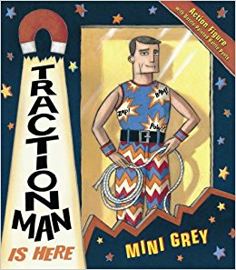

Traction Man is Here
By Mini Grey

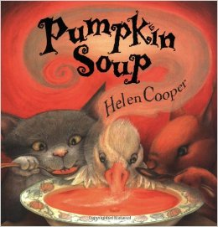

Pumpkin Soup
by Helen Cooper

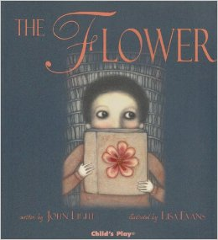

The Flower
By John Light

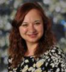
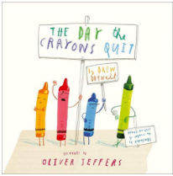
The Day the Crayons Quit
By Oliver Jeffers
Poetry
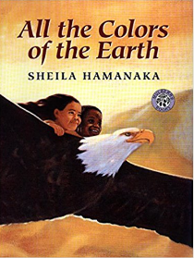
All the colours of the Earth
By Sheila Hamanaka
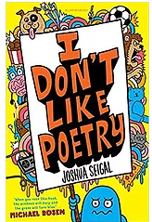
I don’t like poetry
By Joshua Seigal
Stories that we love!
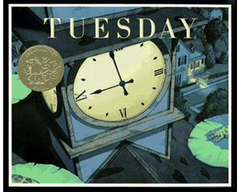

Tuesday
By David Wiesner

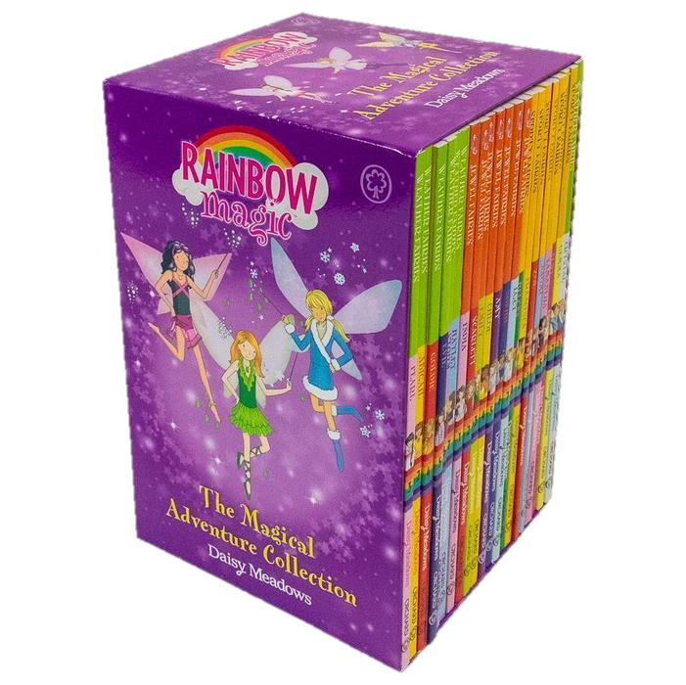

Rainbow Magic Series
By Daisy Meadows
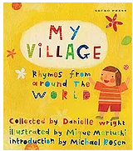
My Village: Rhymes from Around the World
Collected by
Danielle Wright and Mique Moriuchi
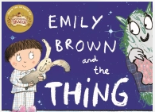

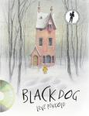

Black Dog
By Levi Pinfold

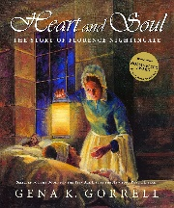
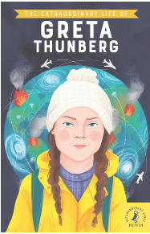
The Extraordinary Life of Greta Thunberg
Non Fiction
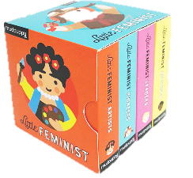
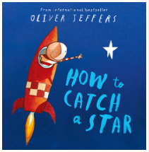
Little Feminists
By Emily Kleinman
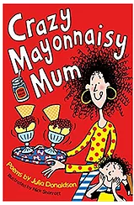
Emily Brown and the THING
By Cressida Cowell
Poet Laureate 2019 - 2021
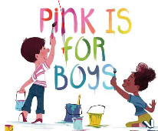
Heart and Soul
By Gena K. Gorrell
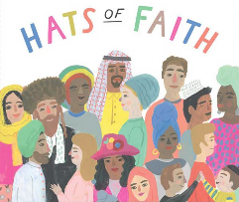
Pink is for Boys
By Robb Pearlman

How to catch a star
By Oliver Jeffers

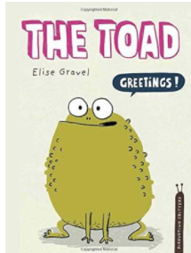
The Toad
By Elise Gravel
Hats of Faith
By Medeia Cohen
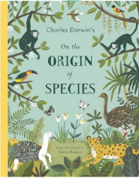
Non-fiction books help children unlock the world around them, but also enable them to participate in reading, tapping into their varied interests and engaging them in a way that stories sometimes can't.
Crazy Mayonnaisy Mum
By Julia Donaldson and Nick Sharratt
On the Origin of species
By Sabina Radeva

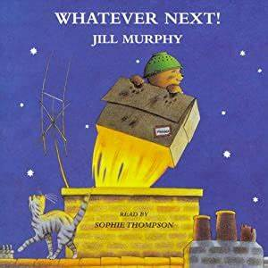
Whatever Next by Jill Murphy

