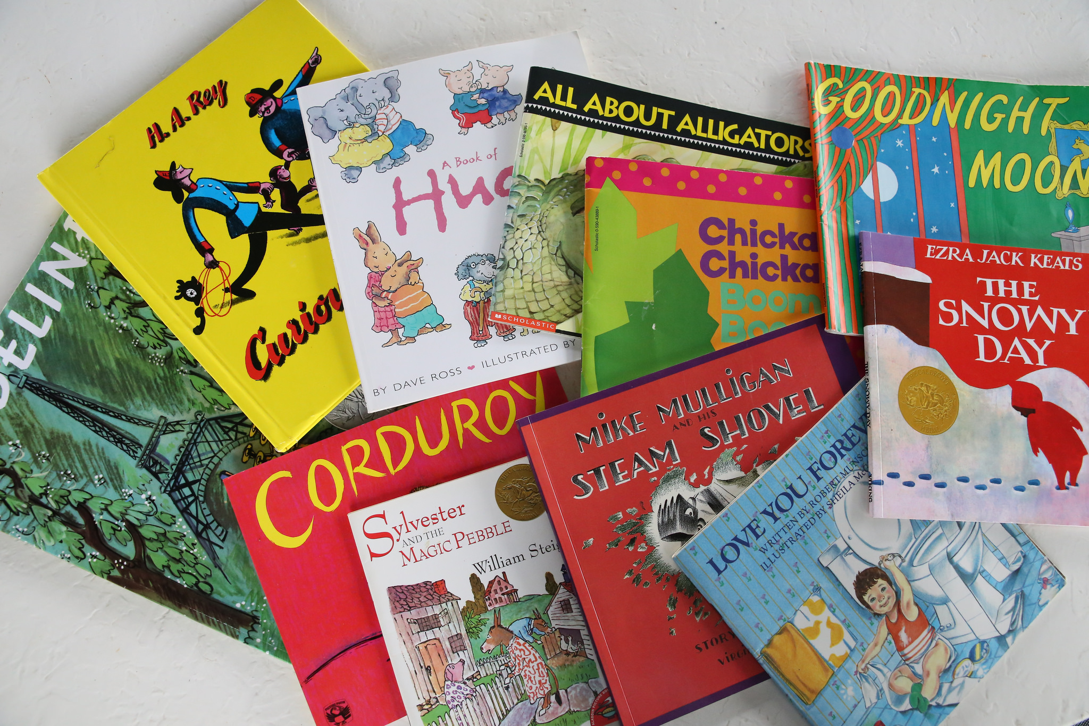
After Reading
Can you retell the story in your own words?
Can you find specific information to answer a question about the text?
Can you discuss how the character is feeling and why? Find evidence in the book
Can you discuss what the character is doing and why?
Can you compare your story to another one you have read? How are they similar and different?
Can you compare the layout, characters, settings and events in the story to your own experiences or to another book?

Before Reading
What do you think this book will be about?
What can you tell me about this book? (author, theme, series)
What type of book do you think it will be?
Why do you think this is a story/poem/ information book?
What can the blurb tell us?
What do you think will happen?
Who do you think is the man character?
Non-Fiction Books
What are the differences between fiction and non-fiction texts?
Can you talk about the main features of the text, e.g. glossary, contents?
What is the difference between a fact and opinion?
Can you find some in your book?
How has the author used paragraphs to organise their ideas?
What are the differences between fiction and non-fiction texts?
Do you need to read a non-fiction book in order?
Can you talk about the main features of the text, e.g. glossary, contents?
What is the difference between a fact and opinion?
Can you find some in your book?
How has the author used paragraphs to organise their ideas?
Can you find 3 new facts you didn’t know before?

Poetry
Why has the author used those words?
What effect is the author trying to create?
Can you find the rhyming words?
Can you clap along to the poem to find the rhythm?
Can you think of other poems that are similar?
What makes this a poem?
During Reading
Why did the character do that?
Can you find a word that describes the character?
Why is the author using those words to describe the character?
Can you discuss the language used to make the story interesting / funny / spooky?
Can you predict what might happen next?
Can you retell the story in your own words?
Can you find specific information to answer a question about the text? E.g.
Why did the Billy Goats want to cross the grass? How do you know?
Can you predict what might happen next?
Can you discuss how the character is feeling and why?
Can you discuss what the character is doing and why?
Can you discuss the language used to make the story interesting / funny / spooky?
Can you compare your story to another one you have read? How are they similar and different? E.g. Can you compare the layout, characters, settings and events in the story to your own experiences or to another book?
Find me the word that means....e.g. find me the word that means happy. (content)

Year 2’s Guide to Reading
Understanding what your child is reading is just as important as decoding words. Please ask your children these questions to help with their home reading.

