WB.29.03.21
LO: I understand that medicines can help me if I feel poorly and I know how to use them safely.
C: Healthy Me piece 4

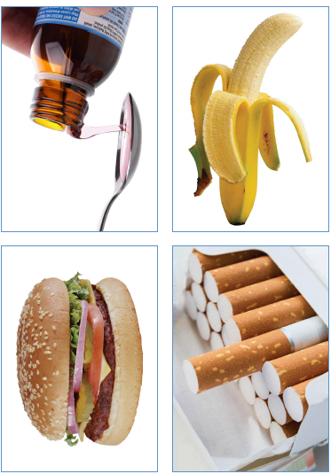
Today we worked in pairs to look at different pictures and sort them into groups to decide which things were always healthy/safe, never healthy/safe or ok sometimes.

WB.29.03.21
LO: I understand that medicines can help me if I feel poorly and I know how to use them safely.
C: Healthy Me piece 4
Today we worked in pairs to look at different pictures and sort them into groups to decide which things were always healthy/safe, never healthy/safe or ok sometimes.

