Wb: 29.03.21 Bubble 11 (1BC) 12 (1LS)
 | 8:30  9:20 | 9:20-10:20 | 10:20-10:30 | 10:30-11:20 | 11:20-11:35 | 11:35-12:10 | 12:10 | 12:30-1 | 1-1:20 | 1:20-2 | 2-2:30 | 2:40-3:20  Home
Mon | Handwriting | RWI  https://www.youtube.com/watch?v=yln6PpV1G1I  Assessment | Break | Maths  Measures assessment | Break | English  Watch the video ‘Saving Easter’ found in the English folder.  Join in with the complete the sentence activities at the end of the video.  Complete the worksheet using red pencil. Remember all the writing rules we know about capital letters, full stops, tenses and question marks. | Assembly | Lunch | Break | Games | Games | Reading
Tues | Handwriting | RWI  https://www.youtube.com/watch?v=yln6PpV1G1I  Assessment | Break | Maths/Computing  What is data?  https://www.bbc.co.uk/bitesize/clips/z9svcdm  . | Break | Easter cards  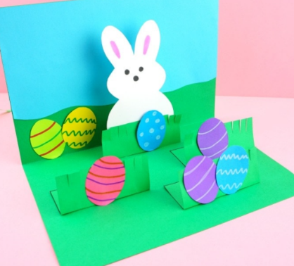 | Assembly | Lunch | Break | Maths Minute  https://www.topmarks.co.uk/maths-games/daily10 | BOLE: | Reading
Weds | Handwriting | RWI  https://www.youtube.com/watch?v=yln6PpV1G1I  Assessment | Break | Maths/Computing  https://www.youtube.com/watch?v=EemjeA2Djjw  Create a tally chart to find out your friends’ favourite ice-cream flavour. | Break | Science  Comparing animals and humans  Watch the video  https://www.bbc.co.uk/bitesize/topics/z6882hv/articles/zx38wmn  What are the basic needs for animals to survive?  Are they the same/different to what humans need to survive? | Assembly | Lunch | Break | Maths Minute  https://www.topmarks.co.uk/maths-games/daily10 | BOLE: | Reading
Thurs | Handwriting | RWI  https://www.youtube.com/watch?v=yln6PpV1G1I  Assessment | Break | Maths/Computing  Use your tally chart to make a bar chart. | Break | RE  At the end of the story Jesus is resurrected and goes up to heaven to be with God. This demonstrates the Christian belief that after they die, they can have a new life in heaven.  Read together the start of Heaven by Nicholas Allen, and discuss both Lil and Dill’s ideas.  Heaven by Nicolas Allan Read by Hailey Book#1 - YouTube  Draw or write what you think Heaven might be like. | Assembly | Lunch | Break | Maths Minute  https://www.topmarks.co.uk/maths-games/daily10  PSHE  Sort the items on the cards into groups: always safe, never safe or sometimes ok. | BOLE: | Reading

