L.O: To write imaginative description wb 17.05.21
Adjectives
hot
boiling
delicious
stripy
blue
flowery
tired
naughty
comfy
C: Peepo
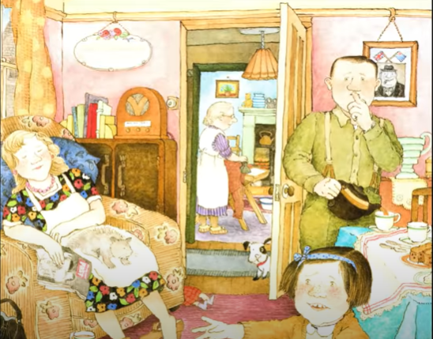

L.O: To write imaginative description wb 17.05.21
Adjectives
hot
boiling
delicious
stripy
blue
flowery
tired
naughty
comfy
C: Peepo



