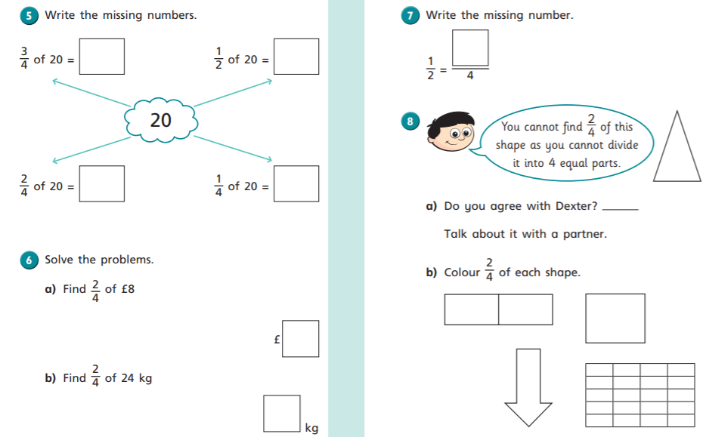

24.05.2021 LO: To use fractions. C: Equivalence of 1/2 and 2/4.
24.05.2021 LO: To use fractions. C: Equivalence of 1/2 and 2/4.

