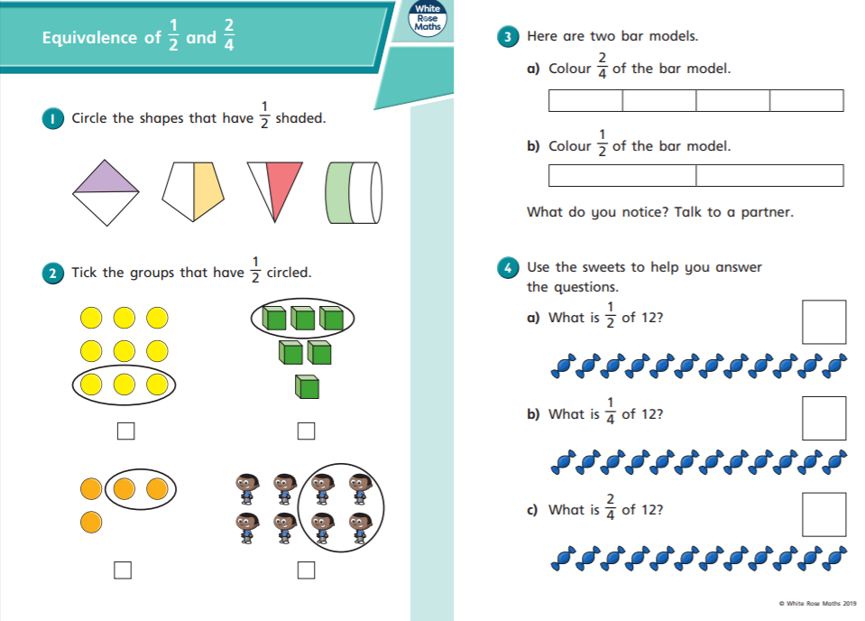

24.05.2021
LO: To use fractions.
C: Equivalence of 1/2 and 2/4.
24.05.2021
LO: To use fractions.
C: Equivalence of 1/2 and 2/4.

