 | 8:30  9:20 | 9:20-10:20 | 10:20-10:30 | 10:30-11:20 | 11:20-11:35 | 11:35-12:10 | 12:10 | 12:30-1 | 1-1:20 | 1:20-2 | 2-2:30 | 2:40-3:20  Home
Mon | Handwriting | RE  Read the story of the Rabbi and the Shoemaker.  Now look at the goals you set on your flag from our first lesson.  What stepping stones can you undertake to help you achieve your goal? Write them on the back of your flag. | Break | Mystery Maths | Break | Voting for class awards | Assembly | Lunch | Break | Games | Games | Reading
Tues |  | Transition activities  Split classes.  Draw a picture of yourself for your new teacher. Write your name and a few facts about you. |  | Science  https://www.youtube.com/watch?v=fy7eoMef3e8  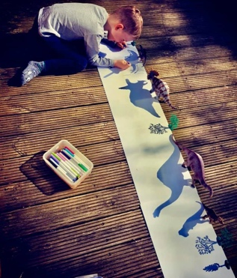  Create art using shadows. Use torches or sunlight depending on the weather.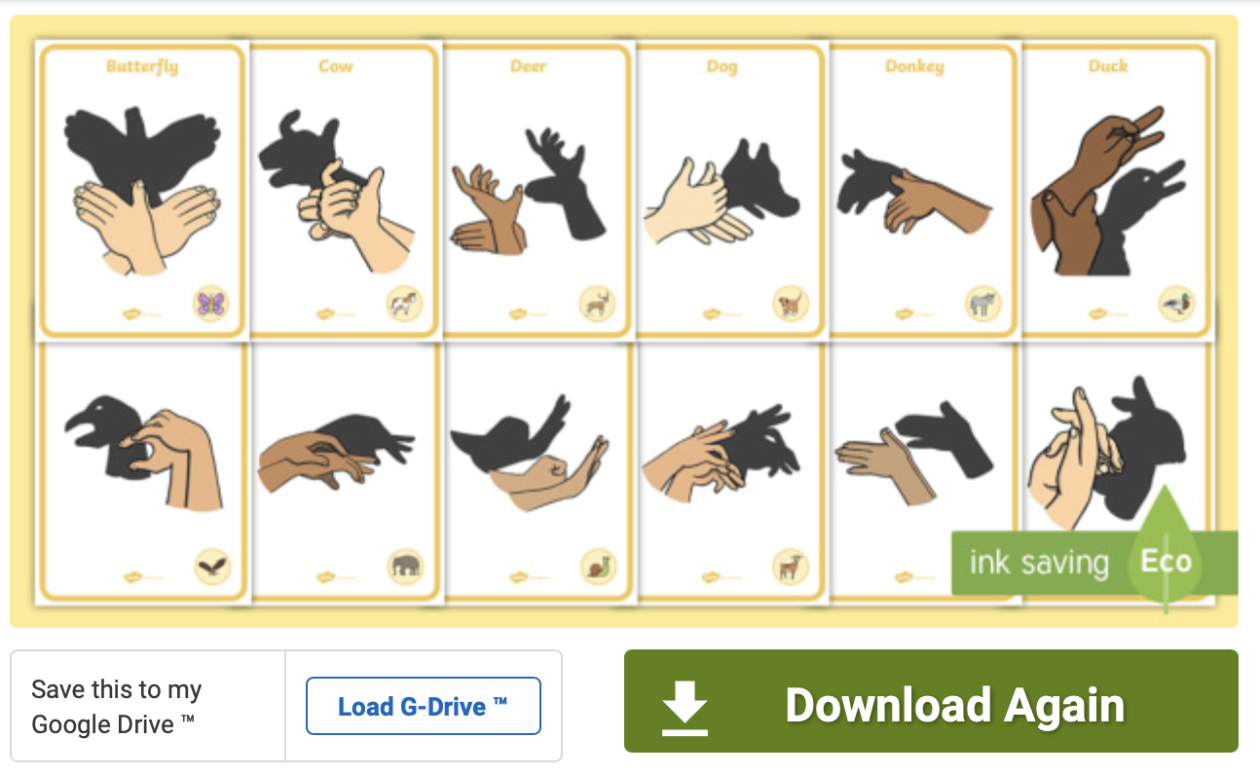 |  | Number blocks  https://www.bbc.co.uk/iplayer/episode/m000t16h/numberblocks-series-5-your-turn
Weds | Handwriting | PSHE  In the box, write a change you have been through. In the speech bubble, write how you felt when this change was happening. | Break | End of year memories | Break | Class awards ceremony | Assembly | Lunch | Break | Tidy trays | BOLE | Reading

