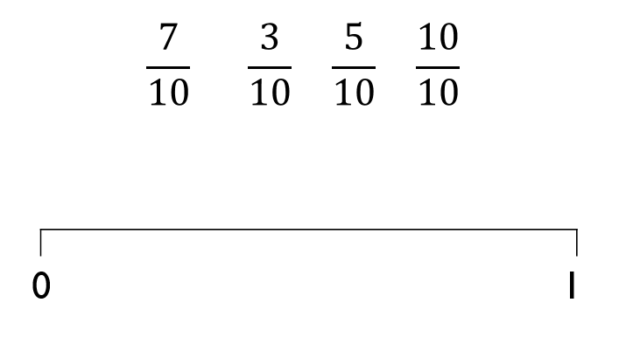

Red Pen Question
Put the fractions on the number line in the correct place.
Red Pen Question
Put the fractions on the number line in the correct place.
Red Pen Question
Put the fractions on the number line in the correct place.
Red Pen Question
Put the fractions on the number line in the correct place.

