
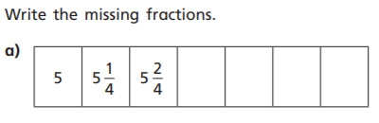
Red Pen Question
Write the missing fractions.
Red Pen Question
Write the missing fractions.
Red Pen Question
Write the missing fractions.
Red Pen Question
Write the missing fractions.
Red Pen Question
Write the missing fractions.
Red Pen Question
Write the missing fractions.

