Tuesday 25th May 2021 L.O: NFER Filling the Gaps C: Adverbs
Today we learned all about adverbs! We played some online games and completed a nugget on Century Tech!
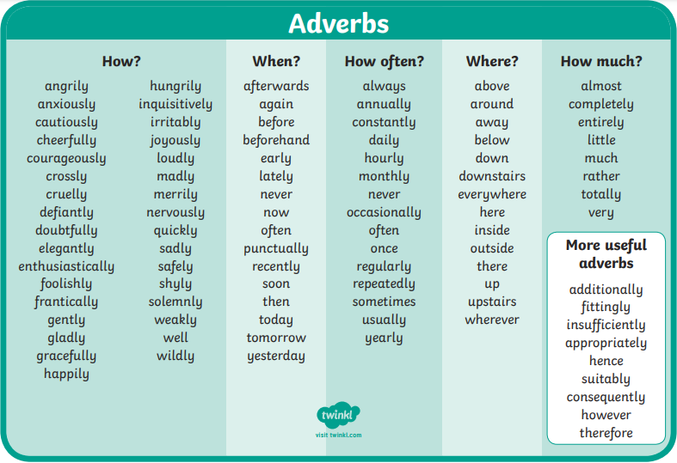

RED PEN QUESTION:
Paddlers:
Carefully select some words from the table, and copy and complete these sentences in your book.
The beautiful ballerina…………………….. leaped across the stage.
Anna looks after her dog, Pippa, by feeding and walking her ……………………..
Snorkellers: Carefully select a word from the table, and copy and complete this sentence in your book.
Percy’s little brother broke his favourite toy, so he stormed out the room ……………………..
Can you write your own sentence using an adverb? Please highlight your adverb.
Divers: Can you write two of your own sentences using an adverb? Please highlight your adverbs.

