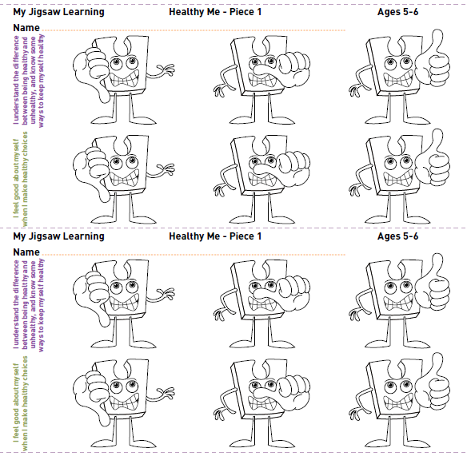

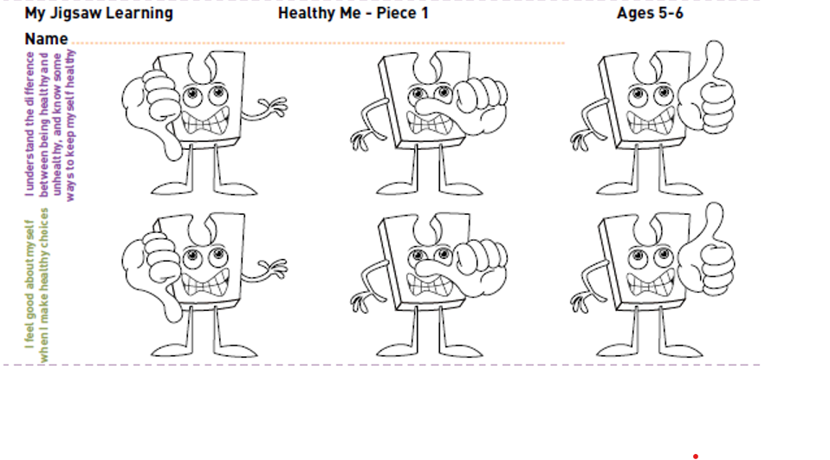

J

WB 08.03.21
LO: I understand the difference between being healthy and unhealthy, and know some ways to keep myself healthy.
C: Healthy Me
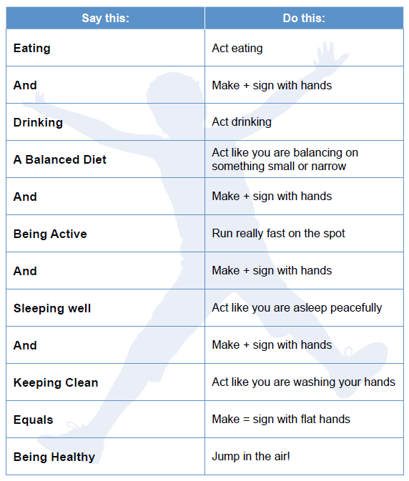
Today we discussed different ways to be healthy and then we acted out the Healthy Balance Sum using actions.

