PSHE: Returning to school after lockdown. Wb 08.03.21

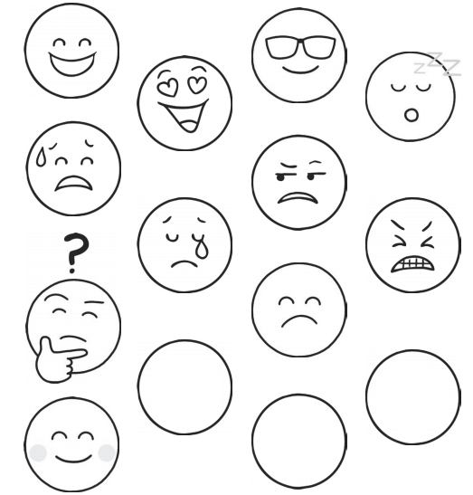
Colour in the faces to show how you feel about being back at school after lockdown. You can choose more than one or you can draw your own if you would like to.

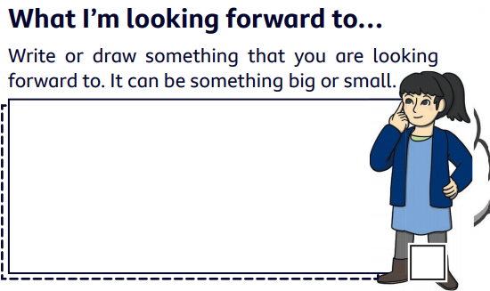
What are you looking forward to now that we are back at school?

