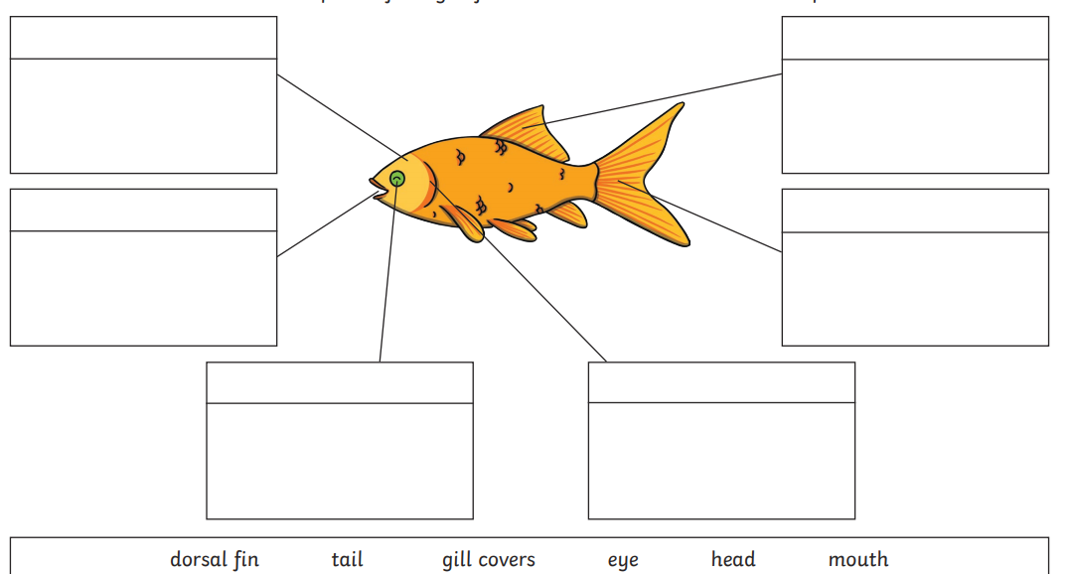
Wb: 10.05.21
L.O: To describe the structure of common animals.

