Book Creator
Create a free account on https://bookcreator.com/
Create a book about your Euro 2020 team’s country (Spain or Italy)with around 3 or 4 pages.
Suggested pages:
- Front cover with a flag
- A picture of some food from that country
- A famous landmark
- Some simple phrases (e.g. hola, buenos dias)
- Include a title for each page
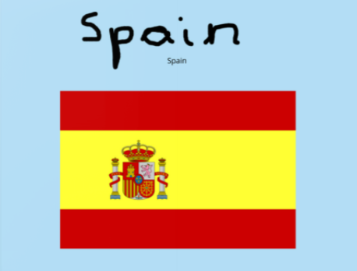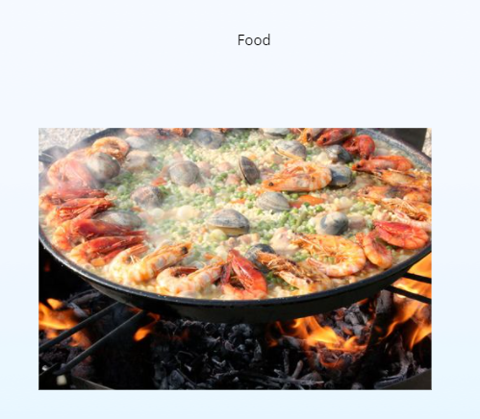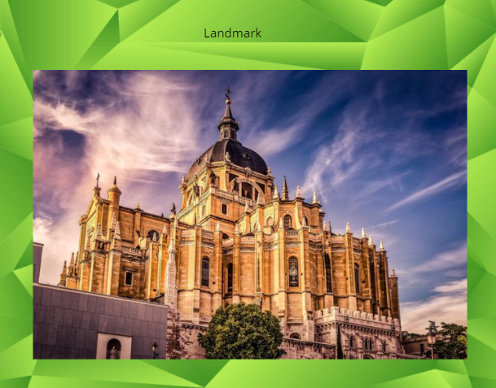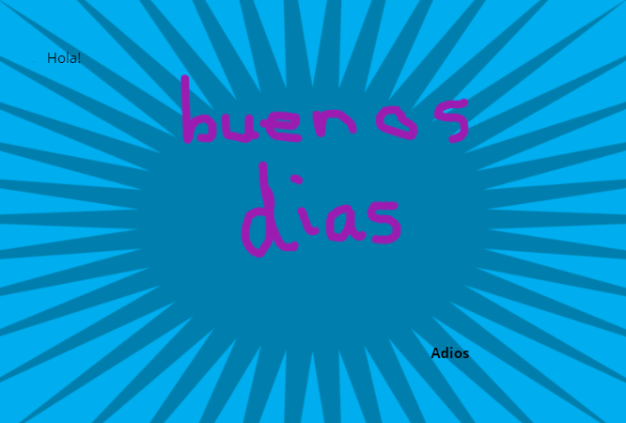

To add a picture, click the cross on the right hand side, click ‘import’ and search for an image.
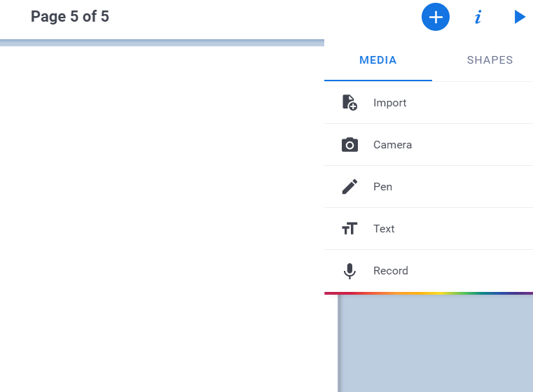
With the same button, you can add text or draw with the pen tool.
Clicking the ‘i’ will allow you to change the background.


