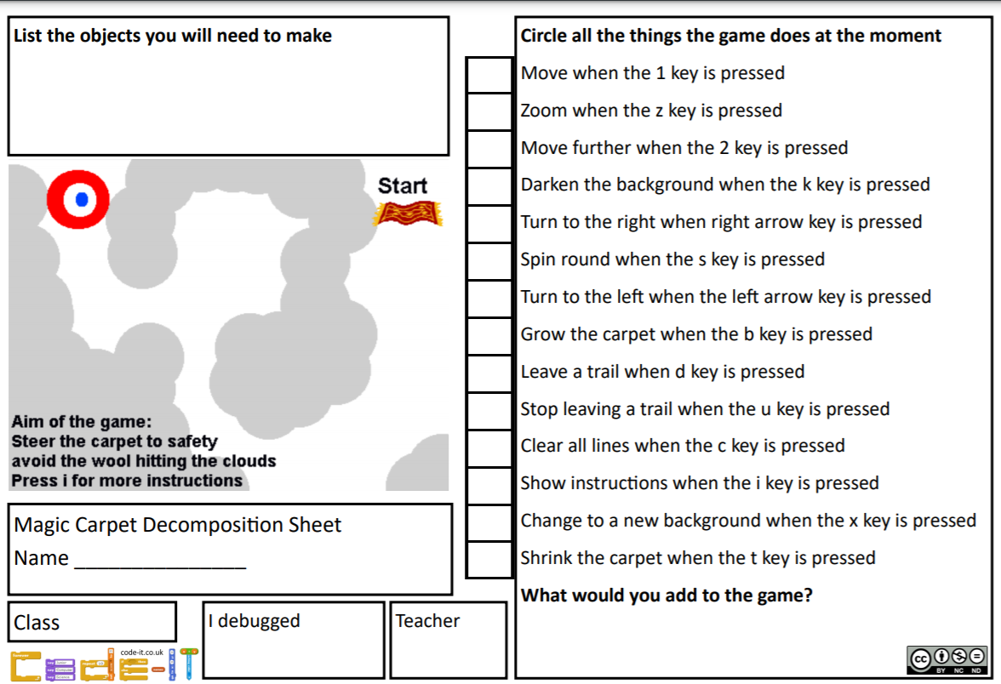
Date: LO: To understand what decomposition is C: Magic Carpet

