WB: 15.03.21
LO: I know how to make healthy lifestyle choices
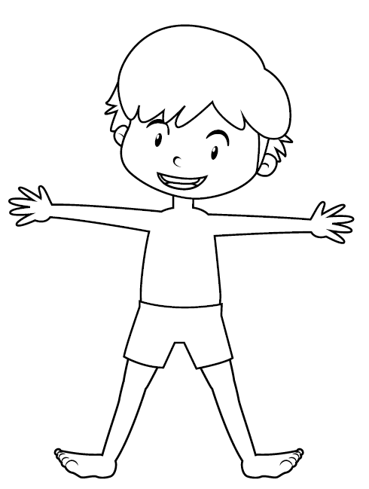
C: Healthy Me piece 2

WB: 15.03.21
LO: I know how to make healthy lifestyle choices
C: Healthy Me piece 2



