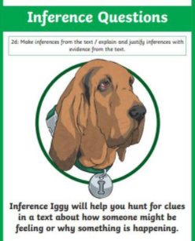

Friday 12th March 2021
L.O: To understand texts- inference skills
C: Boy
Today we discussed negative emotions and how we can overcome them.
- Can you make a mind map bubble to show the emotions the Dahl family went through during the troubled times?
- Despite feeling all of these awful emotions, Roald Dahl’s mother managed to carry on. Discuss with your partner how you think she managed this. You can use the book to help you. Record your findings.

RED PEN CHALLENGE:
- How does Roald Dahl portray his mother as a strong woman?

Friday 12th March 2021
L.O: To understand texts- inference skills
C: Boy
Today we discussed negative emotions and how we can overcome them.
- Can you make a mind map bubble to show the emotions the Dahl family went through during the troubled times?
- Despite feeling all of these awful emotions, Roald Dahl’s mother managed to carry on. Discuss with your partner how you think she managed this. You can use the book to help you. Record your findings.
RED PEN CHALLENGE:
- How does Roald Dahl portray his mother as a strong woman?
Friday 12th March 2021
L.O: To understand texts- inference skills
C: Boy
Today we discussed negative emotions and how we can overcome them.
- Can you make a mind map bubble to show the emotions the Dahl family went through during the troubled times?
- Despite feeling all of these awful emotions, Roald Dahl’s mother managed to carry on. Discuss with your partner how you think she managed this. You can use the book to help you. Record your findings.
RED PEN CHALLENGE:
- How does Roald Dahl portray his mother as a strong woman?

