L.O: To write for purpose Wb: 19.04.21 and 26.04.21
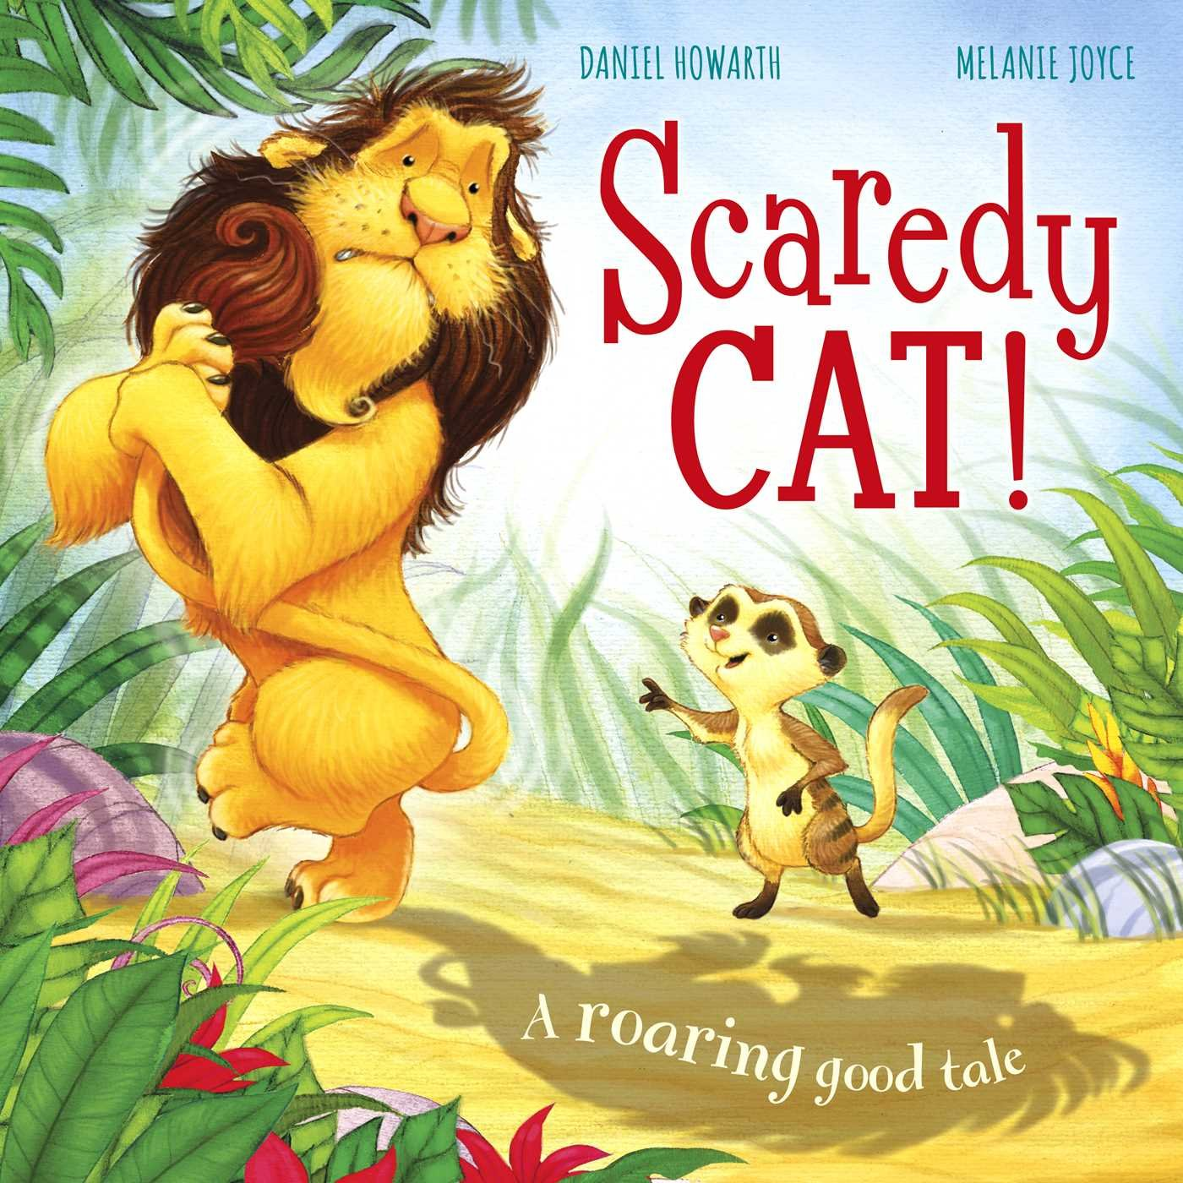
C: Story writing

L.O: To write for purpose Wb: 19.04.21 and 26.04.21
C: Story writing

