LO: To understand beliefs and teachings. Wb 26.04.21
C: The Shabbat Table

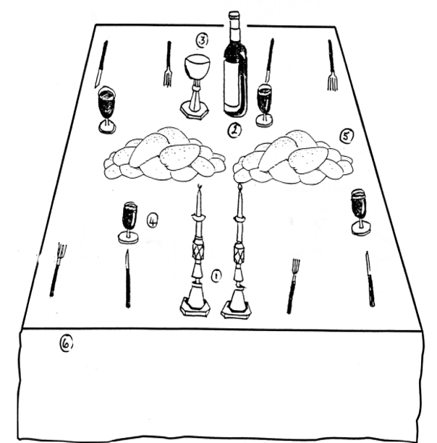

RP - What special traditions do you have in your family?

