To take inspiration wb: 21.06.21
To develop ideas
C: Tingatinga Art

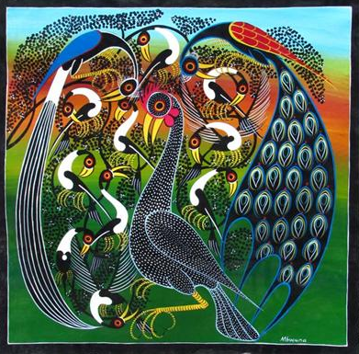

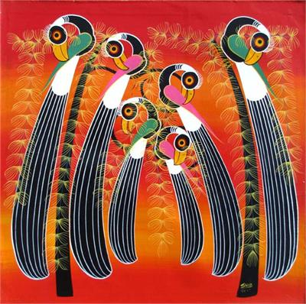
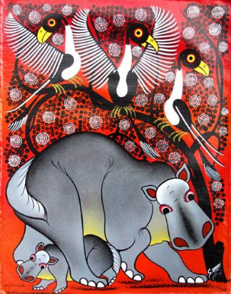

Red pencil: How do these pictures make you feel?
____________________________________________

