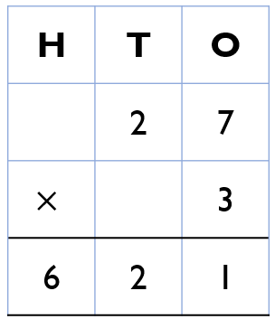
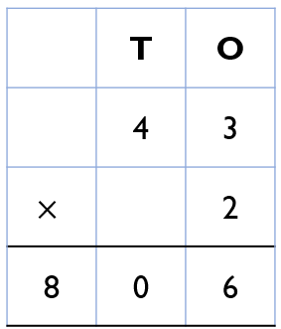
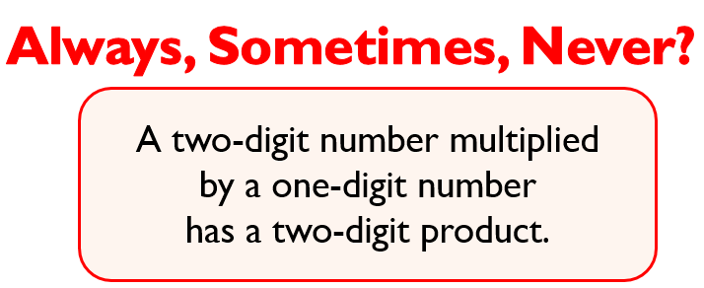
 Work out the answers to the following questions in your books using the formal column method. Remember to set your work out correctly.

- 32 x 4 = 2. 42 x 5 = 3. 62 x 2 =
Correct and explain the mistake:
4. 5.

RP Question

Work out the answers to the following questions in your books using the formal column method. Remember to set your work out correctly.

- 32 x 4 = 2. 42 x 5 = 3. 62 x 2 =
Correct and explain the mistake:
4. 5.

RP Question

