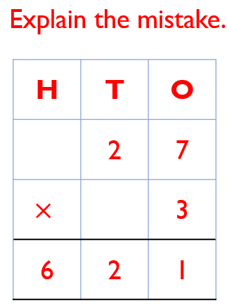
 Work out the answers to the following questions in your books. Remember to set your work out correctly.
- 32 x 4 =
- 42 x 5 =
- 62 x 2 =
- 25 x 3 =
- 74 x 4 =

RP Question:

Work out the answers to the following questions in your books. Remember to set your work out correctly.
- 32 x 4 =
- 42 x 5 =
- 62 x 2 =
- 25 x 3 =
- 74 x 4 =

RP Question:

Work out the answers to the following questions in your books. Remember to set your work out correctly.
- 32 x 4 =
- 42 x 5 =
- 62 x 2 =
- 25 x 3 =
- 74 x 4 =

RP Question:

Work out the answers to the following questions in your books. Remember to set your work out correctly.
- 32 x 4 =
- 42 x 5 =
- 62 x 2 =
- 25 x 3 =
- 74 x 4 =

RP Question:

