

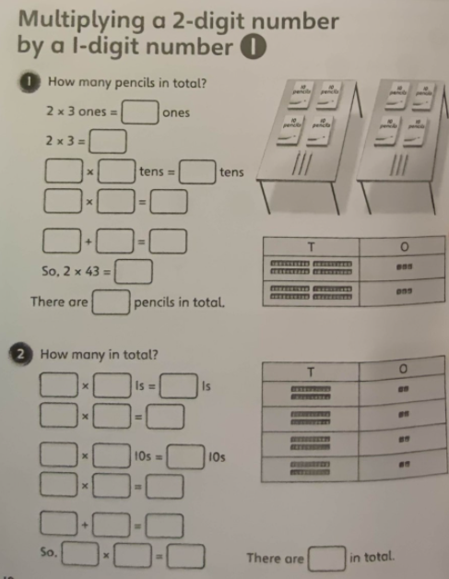

RP: In your books, can you work out the following questions using the formal column method?
- 24 x 2 = 2. 32 x 3 = 3. 24 x 5=

