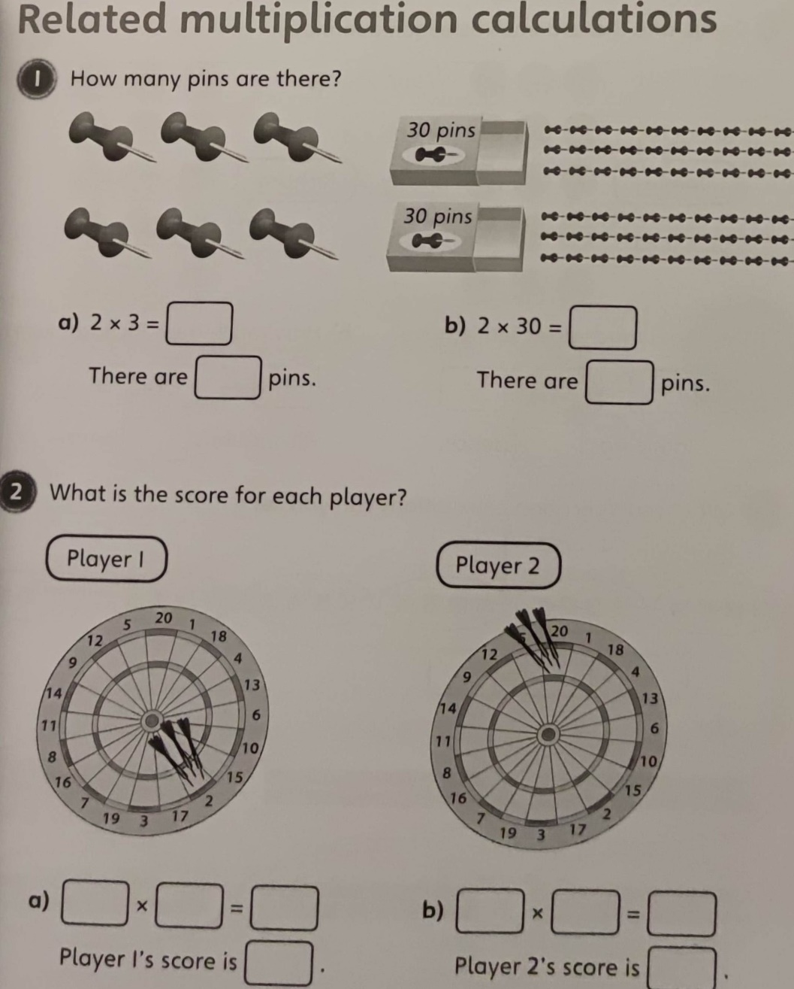
08.03.2021
LO: To multiply and divide
C: Multiply 2-digits by 1-digit (recap from home learning)
Starter activity:

08.03.2021
LO: To multiply and divide
C: Multiply 2-digits by 1-digit (recap from home learning)
Starter activity:

