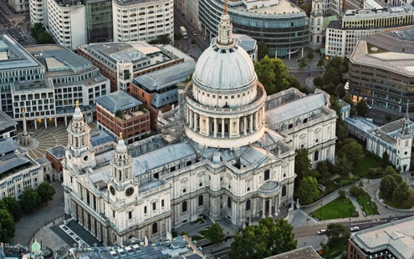
L.O: To locate places and describe features
C: London
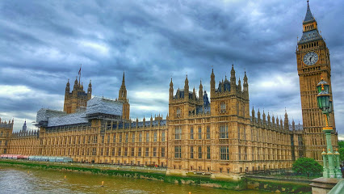
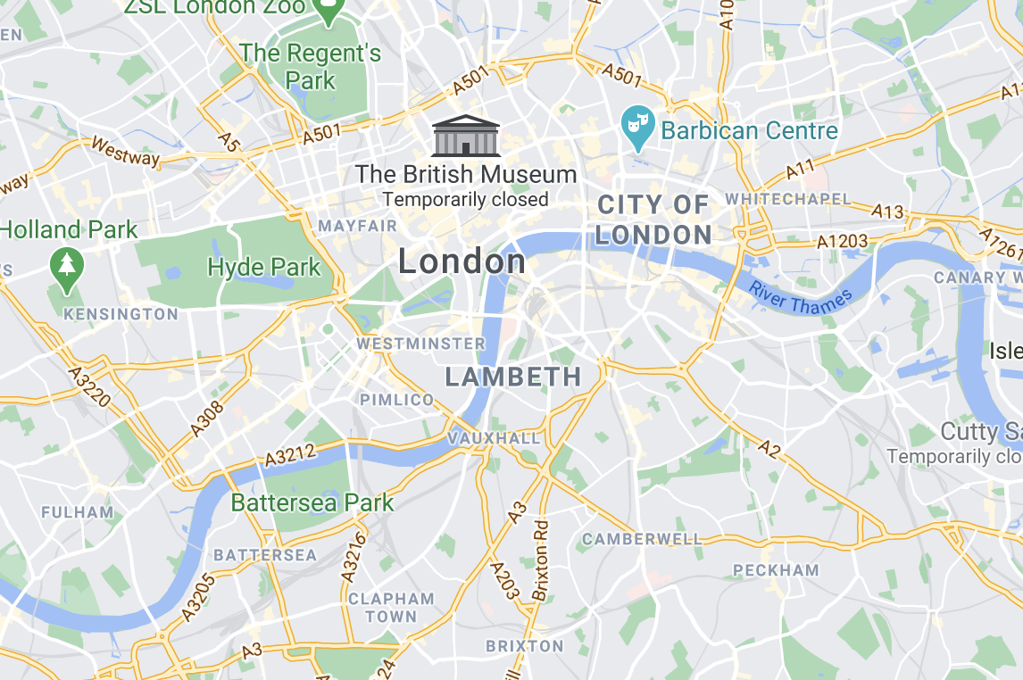

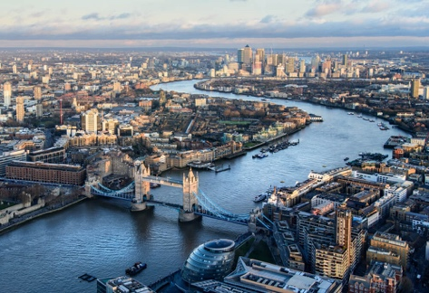
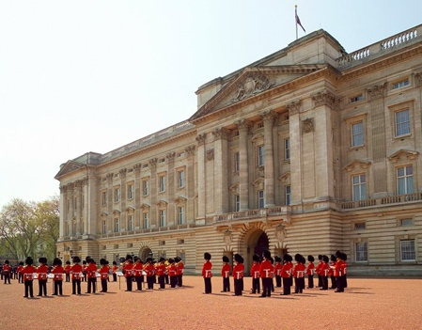

St Paul’s Cathedral Buckingham Palace Houses of Parliament River Thames

Challenge: Which of these famous landmarks are manmade and which are natural?

