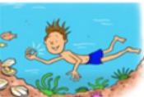
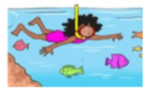
Monday 8th March 2021
L.O: To understand texts- prediction
C: Boy
Today we began to investigate our new class read. We gradually revealed the book cover and made a series of predictions.
The author is… | Prompts | Prediction
- What kind of books does he usually write?
- What genre are they?
- What might the audience for this book be?
- What kind of language are you expecting to find?
The title is… | Prompts | Prediction
- How has your prediction changed?
- What do you think this book might be about?
- What audience do you think this book is aimed at?
The front cover… | Prompts | Prediction
- How has your prediction changed?
- What do you think this book might be about?
- How do the pictures influence your prediction? What can you see? What is he wearing?
The blurb… | Prompts | Prediction
- How has this blurb changed and influenced your current prediction?
- What theme might this book be?
- Has your predicted audience changed?

