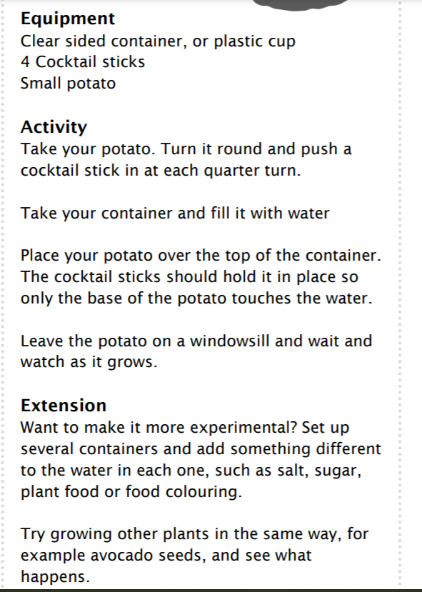

Take photos of your potato and observe the potato. Make notes on the sheet provided on what you notice.

This is a fun way to notice root development.

