Snorkelling and Diving
Name each shape and find the overall perimeter showing your working out in your book. **Remember to write the units**
(2)
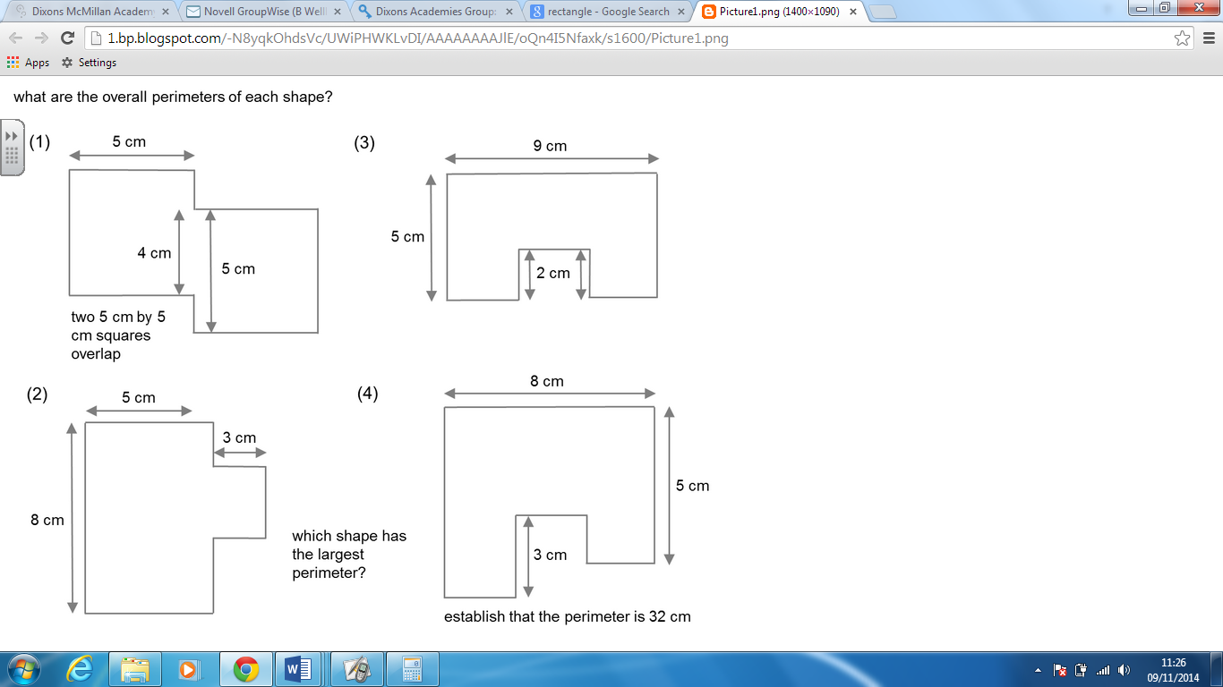
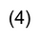
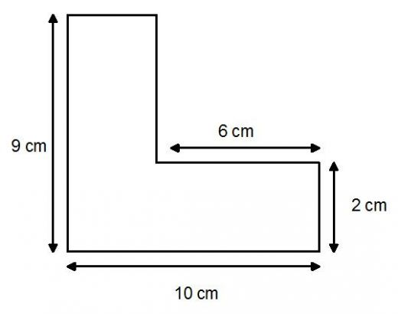
(3)

