
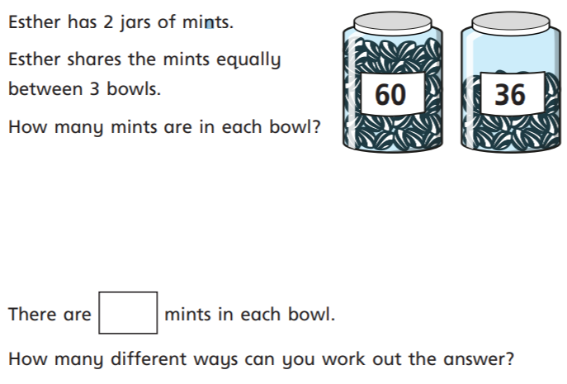
09.03.2021
L.O: Multiplication and Division
C: To divide 2 digits by 1 digit (1)
1) Solve the following questions using the part-whole model
- 84 ÷ 4 = b) 96 ÷ 3 =
c) 77 ÷ 7 = d) 68 ÷ 2 =
2)
RP: Which method (physical place value counters, drawing place value counters or using the part-whole model) do you prefer to use when solving a division question? Explain your answer.
09.03.2021
L.O: Multiplication and Division
C: To divide 2 digits by 1 digit (1)
1) Solve the following questions using the part-whole model
- 84 ÷ 4 = b) 96 ÷ 3 =
c) 77 ÷ 7 = d) 68 ÷ 2 =
2)
RP: Which method (physical place value counters, drawing place value counters or using the part-whole model) do you prefer to use when solving a division question? Explain your answer.

