
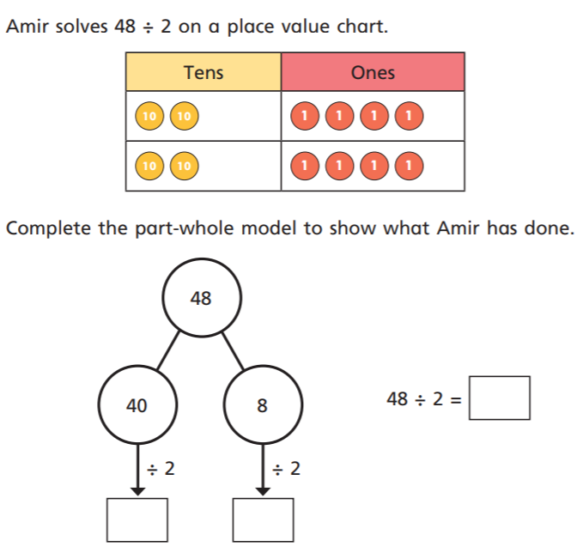
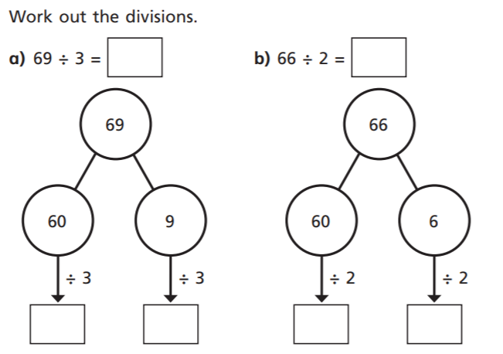
2)
2)
1)
1)
09.03.2021
L.O: Multiplication and Division
C: To divide 2 digits by 1 digit (1)
09.03.2021
L.O: Multiplication and Division
C: To divide 2 digits by 1 digit (1)

