

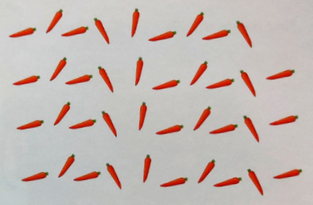
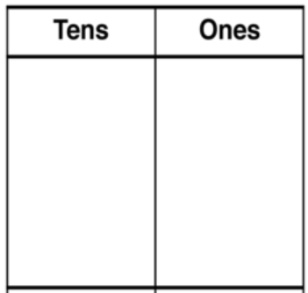
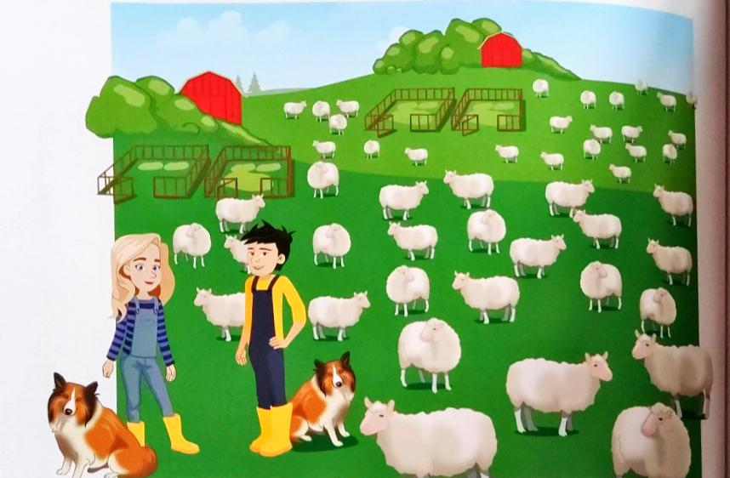
RP: Did you find it quicker to solve the calculations using physical place value counters or by drawing the place value counters. Explain your answer.
2)
A farmer has 39 carrots and 3 horses.

- What number sentence represents this question?

- How many carrots will each horse get?

- Complete the table to show how you solved this question.

Use your place value counters to solve the questions below.
1)
On a farm, there are 42 sheep.
The sheep are shared equally between the 2 farmers.
- How many sheep will each farmer have?

The sheep are shared equally between the pens on the farm.
- How many pens are on the farm?

- What number sentence represents this question?

- How many sheep are in each pen?

09.03.2021
L.O: Multiplication and Division
C: To divide 2 digits by 1 digit (1)

