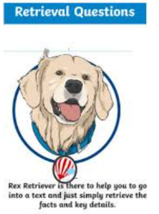
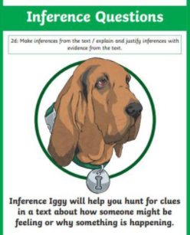
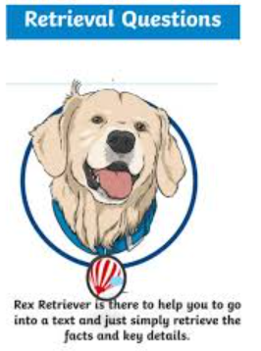
Tuesday 9th March 2021
L.O: To understand texts- retrieval
C: Boy
Today we began to read our new book, and used our reading dogs skills to answer these questions.
- What is an autobiography? (1 mark)
- Look at page 3. What do you think “prosperous” means? Afterwards, find an accurate definition from a dictionary. (2 marks)
- How do you think Roald’s father felt when they pulled his arm? (2 marks)

RED PEN CHALLENGE:
- Do you think Roald is proud of his father? Why? Why not?
Tuesday 9th March 2021
L.O: To understand texts- retrieval
C: Boy
Today we began to read our new book, and used our reading dogs skills to answer these questions.
- What is an autobiography? (1 mark)
- Look at page 3. What do you think “prosperous” means? Afterwards, find an accurate definition from a dictionary. (2 marks)
- How do you think Roald’s father felt when they pulled his arm? (2 marks)
RED PEN CHALLENGE:
- Do you think Roald is proud of his father? Why? Why not?

Tuesday 9th March 2021
L.O: To understand texts- retrieval
C: Boy
Today we began to read our new book, and used our reading dogs skills to answer these questions.
- What is an autobiography? (1 mark)
- Look at page 3. What do you think “prosperous” means? Afterwards, find an accurate definition from a dictionary. (2 marks)
- How do you think Roald’s father felt when they pulled his arm? (2 marks)
RED PEN CHALLENGE:
- Do you think Roald is proud of his father? Why? Why not?

