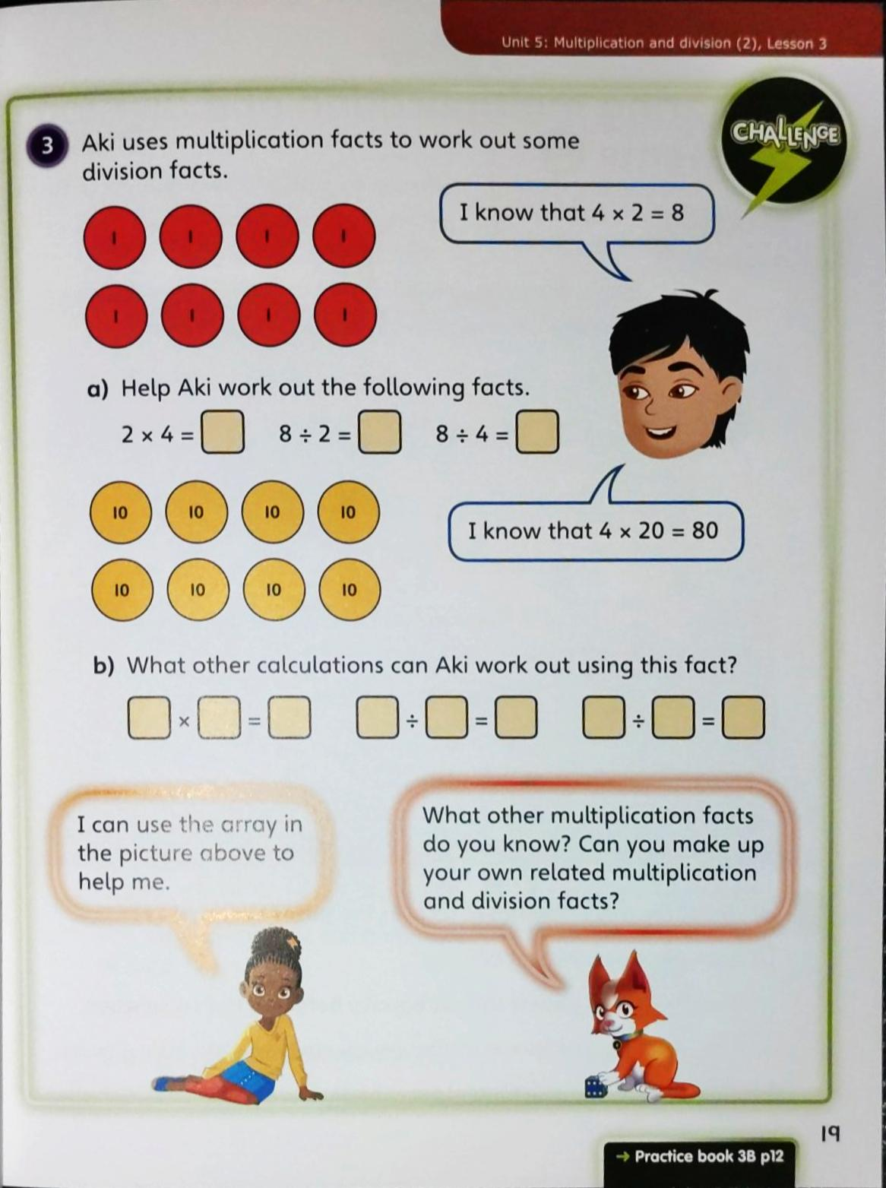
10.03.2021
L.O: Multiplication and Division
C: Divide 2-digits by 1-digit (2)

Starter:
We used place value counters to solve some division questions (see the picture below.

RP: Today’s learning was different from yesterday’s learning because…

10.03.2021
L.O: Multiplication and Division
C: Divide 2-digits by 1-digit (2)

Starter:
We used place value counters to solve some division questions (see the picture below).

RP: Today’s learning was different from yesterday’s learning because…

