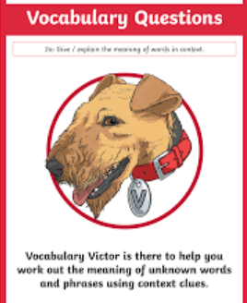
Wednesday 10th March 2021
L.O: To understand texts- vocabulary
C: Boy
Today we continued our new class read. We went on a vocabulary treasure hunt.
Word | Use in the text | Meaning | Marking/correction
amiable | - “Their own father, an amiable giant nearly seven foot tall…”
tomfool | “he refused to support this tomfool idea.”
forbade | “When he forbade them to go…”
trawlers | “He owned a fleet of trawlers…”
château | - “a large château in the country…”


RED PEN Challenge:
Can you use one of the new words in a sentence?

