Thursday 11th March 2021
- Can you circle the county Binfield is in?
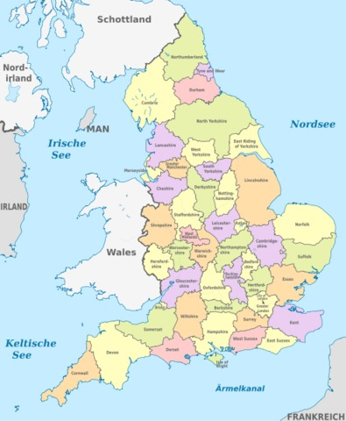
L.O. To investigate places.
C: Continents and countries.
- Can you circle the continent Binfield is in?
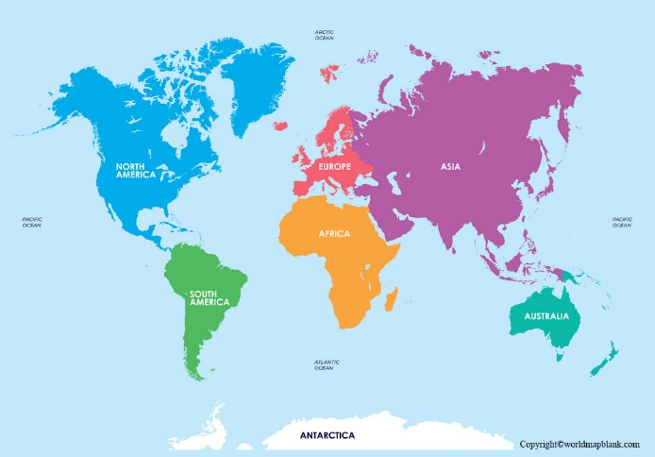

- Can you label Binfield on this map of ______________?
- Can you circle the country Binfield is in?


