Read chapters 7 and 8.

If you have not already completed this task pleas do so:
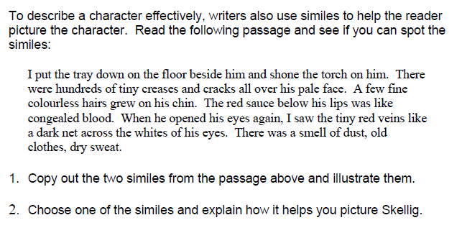

If you have already completed this this task have a go at the following tasks:

- Write two similes of your own to describe Skellig and illustrate them.
- Choose one of the similes and explain how it helps you picture Skellig.

Here are some examples to help you:
His | face  hands  hair  suit | was like  were like  looked like  was as | a hollow skull.  paper.  old cobwebs.  stained and tattered as an old dust-sheet.

