
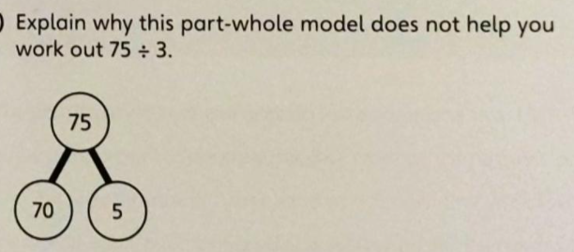
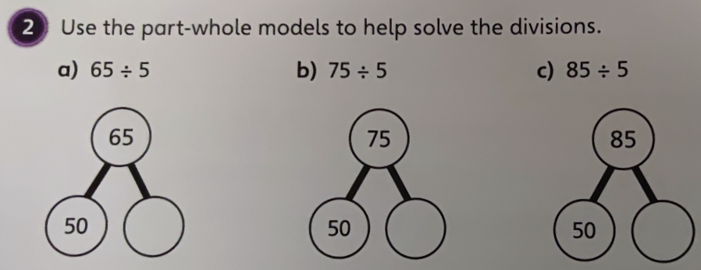
11.03.2021
L.O: Multiplication and Division
C: Divide 2-digits by 1-digit (2)

- Can you solve the following division questions by drawing and completing the part-whole models..
2) Now try these by drawing part whole-models:

a) 78 ÷ 6 = b) 84 ÷ 3 = c) 70 ÷ 5 = d) 96 ÷ 4 =

RP: Explain why the part-whole model does not help you solve 75 ÷ 3.
11.03.2021
L.O: Multiplication and Division
C: Divide 2-digits by 1-digit (2)

- Can you solve the following division questions by drawing and completing the part-whole models..
2) Now try these by drawing part whole-models:

a) 78 ÷ 6 = b) 84 ÷ 3 = c) 70 ÷ 5 = d) 96 ÷ 4 =

RP: Explain why the part-whole model does not help you solve 75 ÷ 3.

