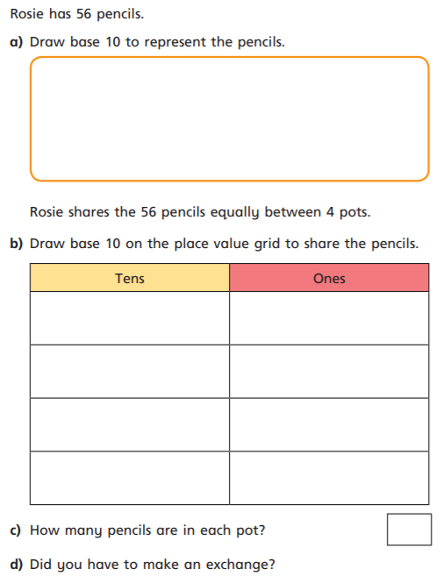

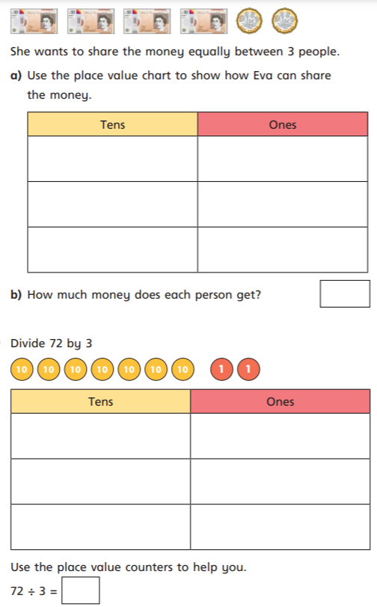
11.03.2021
L.O: Multiplication and Division
C: Divide 2-digits by 1-digit (2)

