Digimaps for Schools
Login https://digimapforschools.edina.ac.uk/login
Login details:
Username: RG42 4EW
Password: choves5925
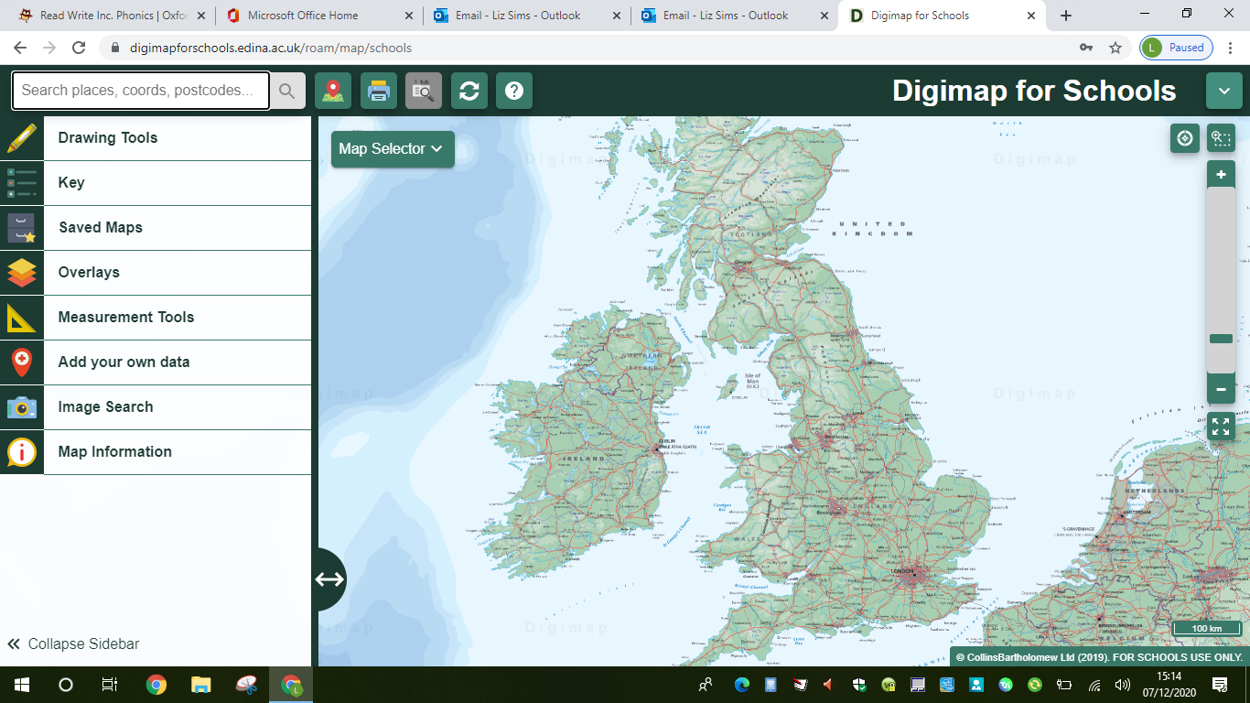
Have a go at doing the following tasks:
- Search for the school in the search tab.
- Try changing the map selector.

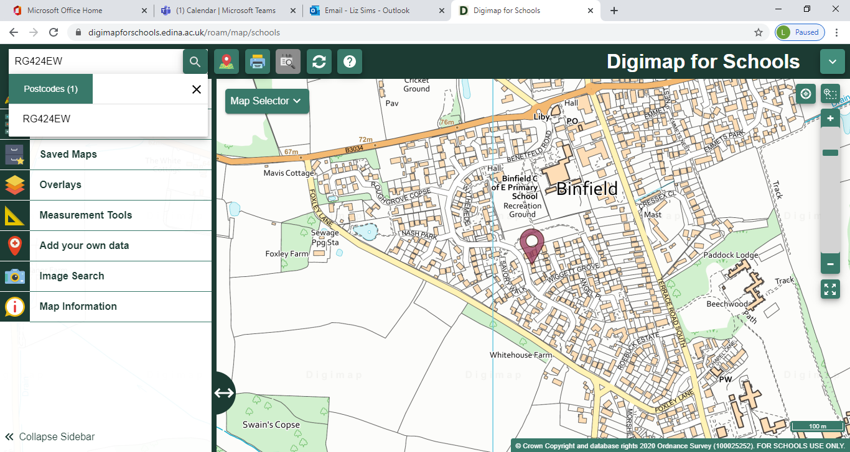
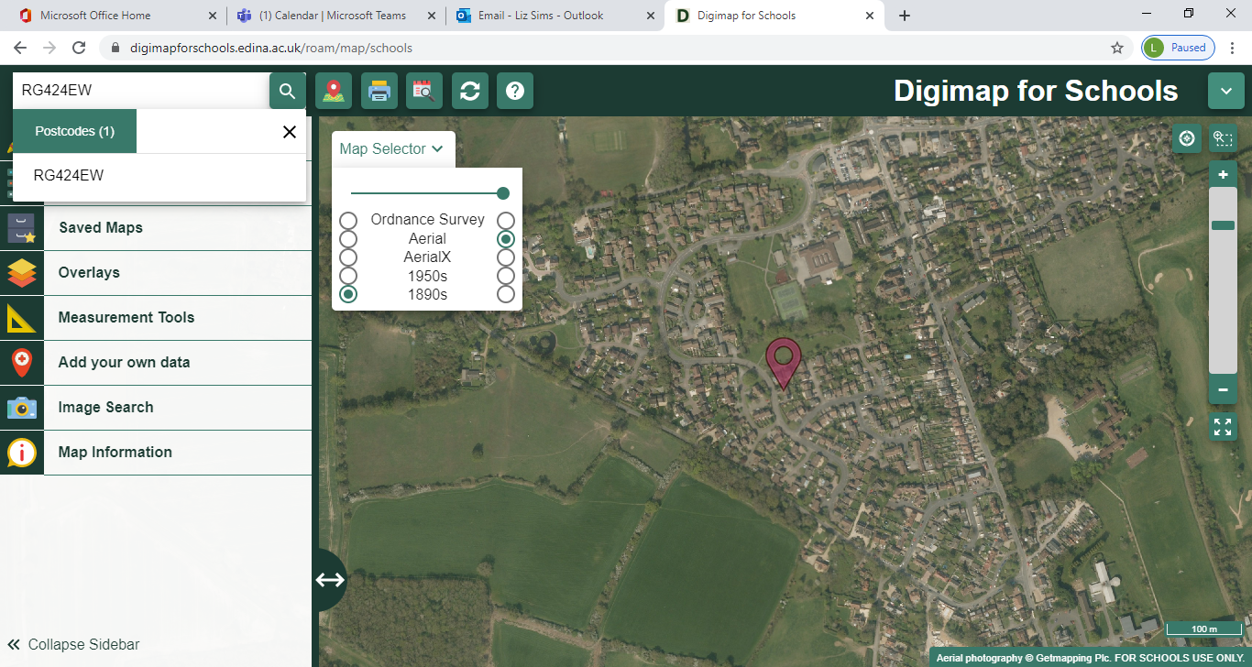

How was the area different in the past?
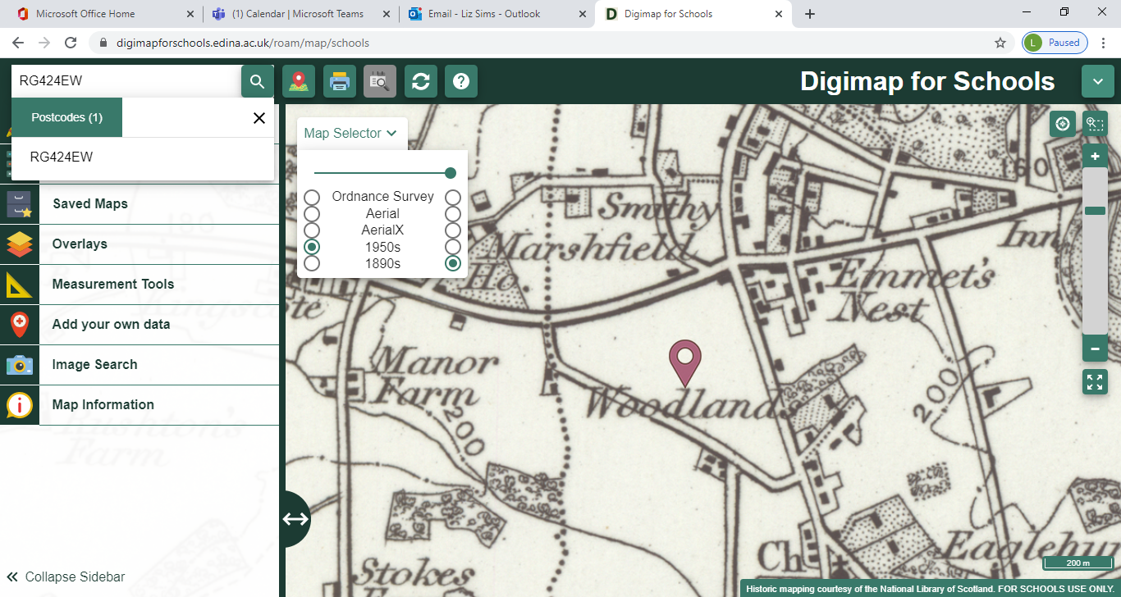

- How far is it from the school to The Warren? Are there different ways you could measure this?
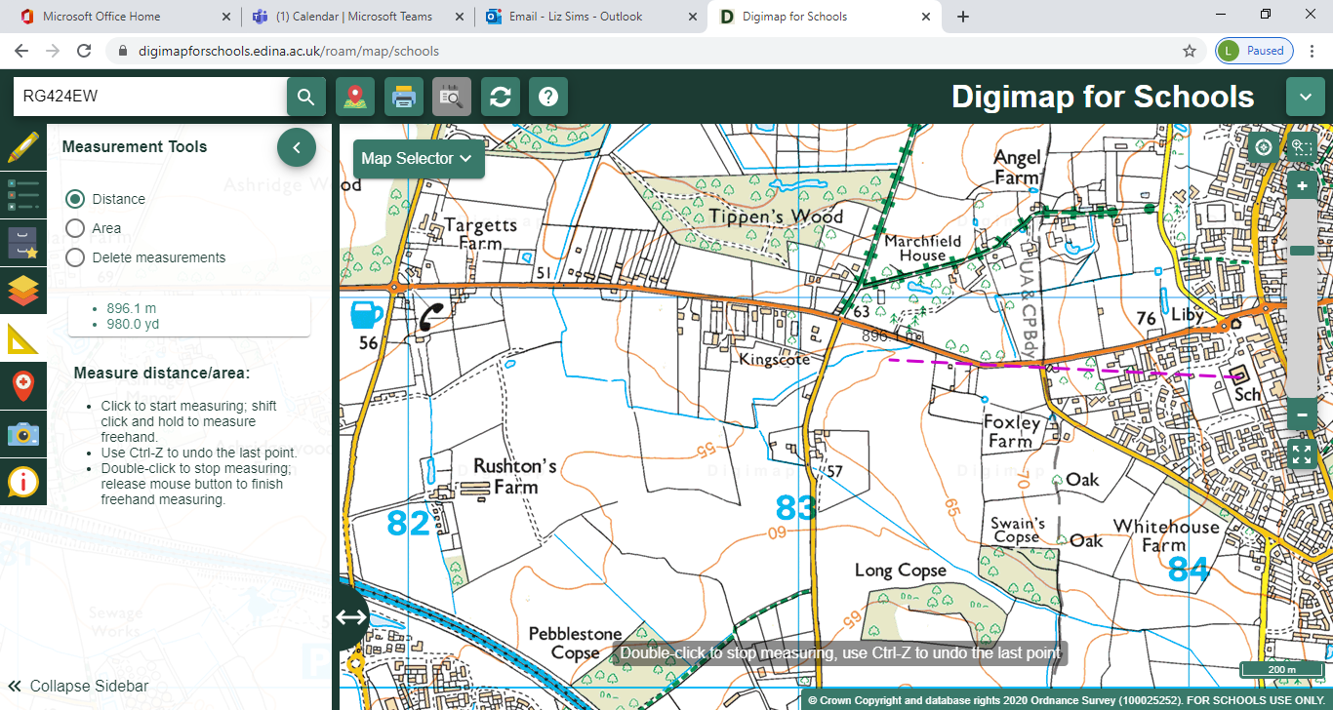

- Put a marker by your house and the school. Add a text box. How far is it between the points?

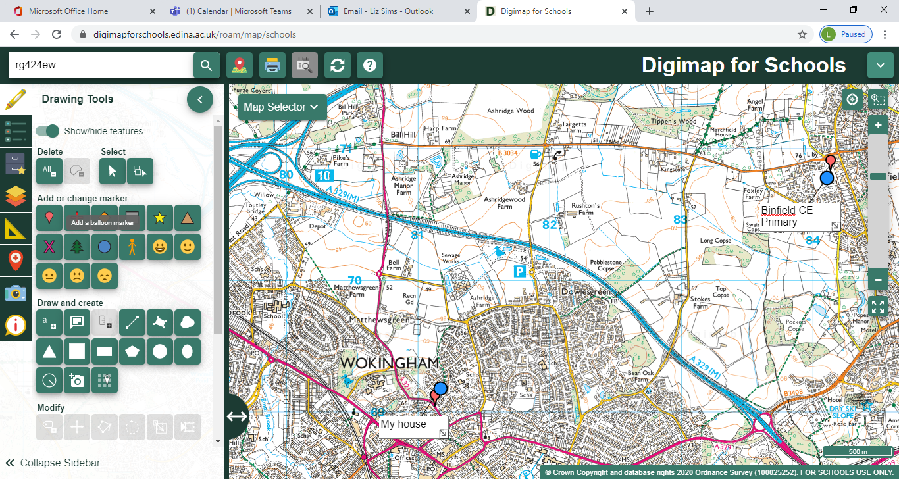

- Measure the area of the Junior Playground using the measurement tools. Is it bigger, or smaller than the Infant Playground?
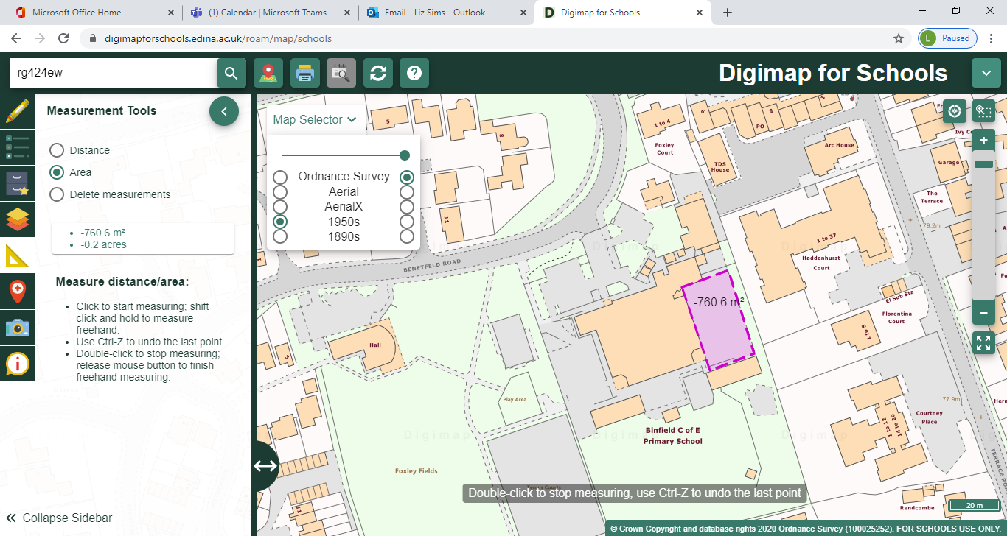

- What is the distance between the Tropic of Cancer and the Tropic of Capricorn?
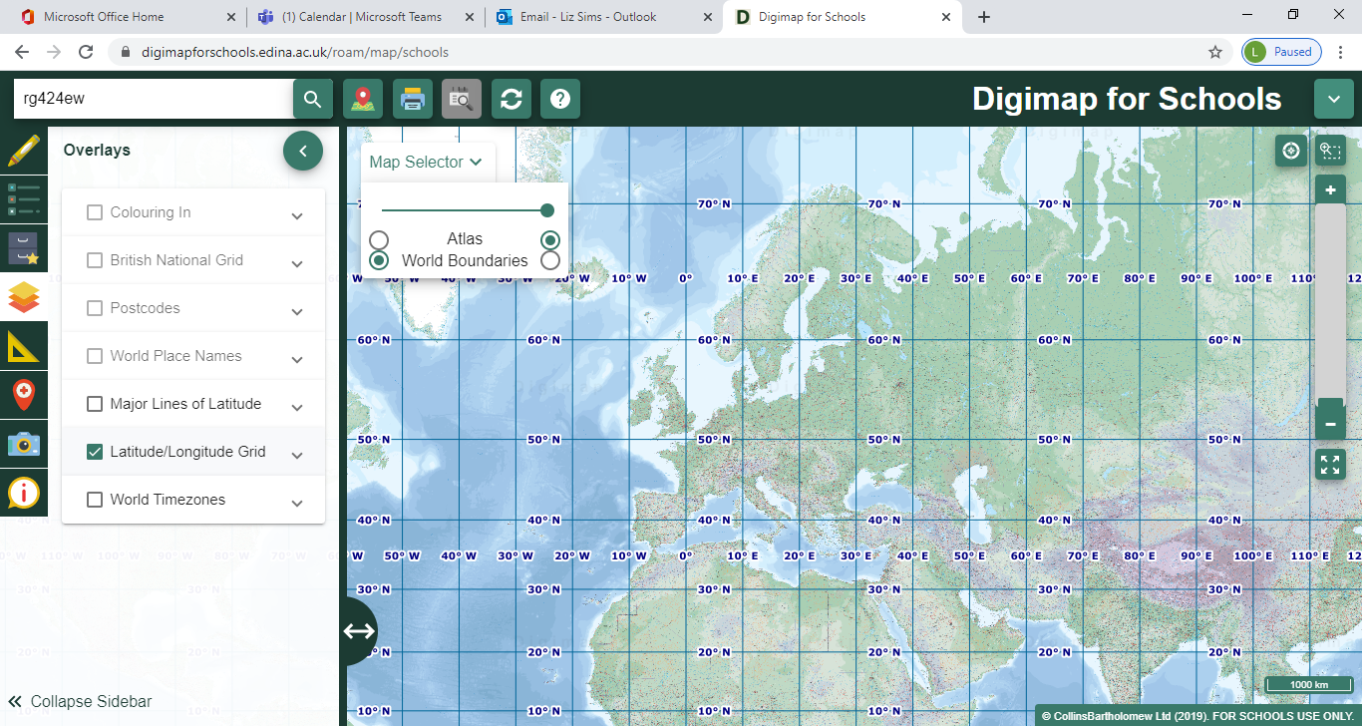

- What it the time difference between Binfield and Athens?
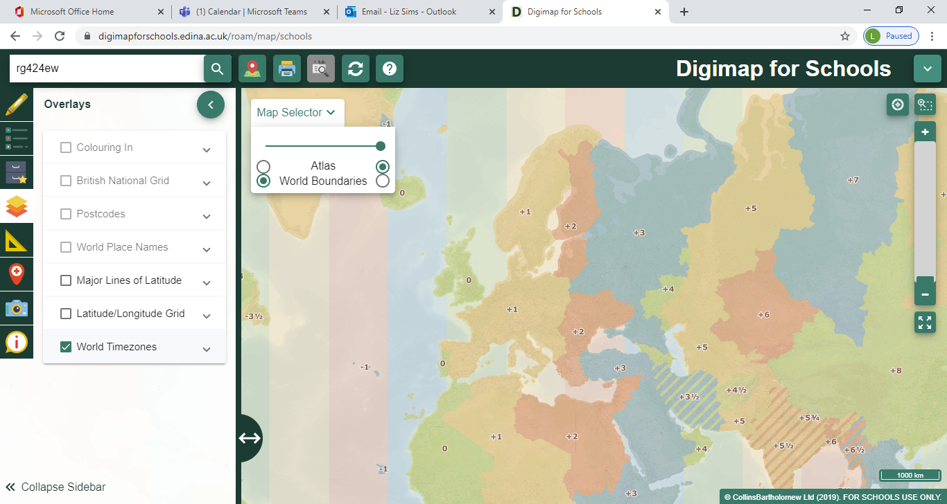

- What is the grid reference for the library? Click on coordinate capture in ‘i’ and click the on the map at the correct location.


