Homophones are words which sound the same but are spelt differently and have different meanings.
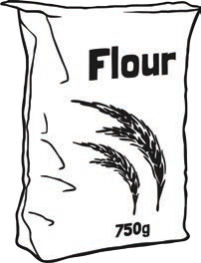
Match the pictures to the words.

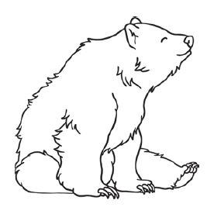  1 | 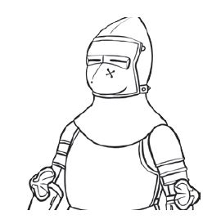  2 | 3 | 4  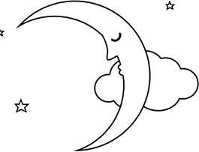
5  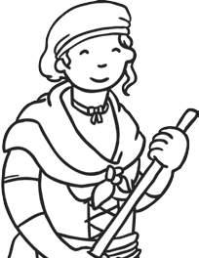 | 6  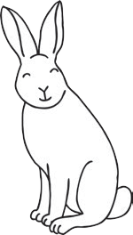 | 7  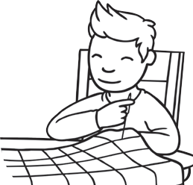 | 8  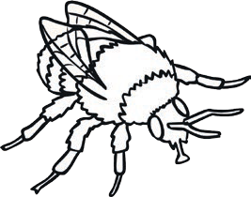
9  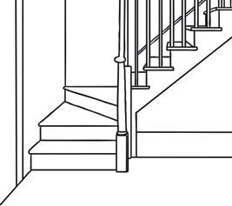 | 10  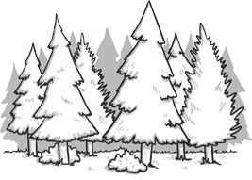 | 11  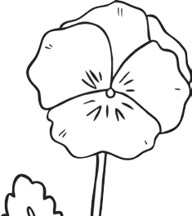 | 12  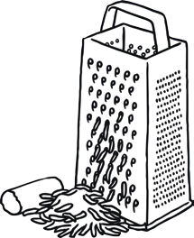

 | bare |  | bear |  | maid |  | would
 | wood |  | grate |  | knight |  | hare
 | flower |  | stair |  | night |  | bee
 | sew |  | be |  | so |  | flour
 | great |  | hair |  | made |  | stare

