No More School?
by Douglas Hill
It was in May that Kevin Barnes began to wish more than anything that he didn’t have to go to school.
Kevin was in his first year at the local comprehensive, and for most of that year he hadn’t minded school at all. But in the spring everything had changed. For Kevin, school became a place to keep away from. Not because he was bored or anything, but because he was frightened – by something only he knew about.
It had started one day, when Kevin was staring out of the classroom window at the big tree just beyond the fence. It was a half-dead sycamore that had been blasted during the winter by a windstorm and a bolt of lightning, at the same time. Or so people said.
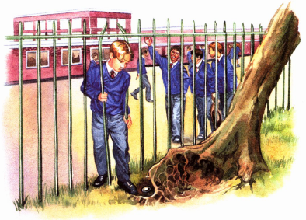
As he gazed at the tree, the sunlight hit something under its torn-up roots. It was something bright, glinting like shiny glass.
When it was break, he went out to investigate. They weren’t really supposed to, but Kevin decided to squeeze through one of the gaps between the bars of the fence.
‘Where are you going, Kev?’ called one of his friends.
Paying no attention, Kevin stooped down and peered under the tree. And there it was, the shiny thing he had seen. Picking it up, he saw a metal object, very shiny and perfectly smooth, about the shape and size of a small egg.
Kevin had no idea what it could be. A weird thought came to him – that it was a mini-spaceship which had arrived with the lightning that had blasted the tree.
As he smiled, he was turning the thing over and over in his hands, feeling its smooth shininess.
And as he twisted it, it came open.
It fell apart in two bits. And there was something inside. Kevin shook it out into his hand and saw that it looked like a strange sort of insect – brown and shiny, curled up like a woodlouse and about the same size.
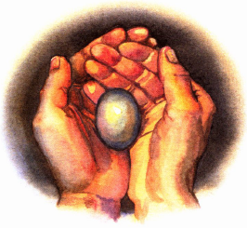
At that moment, it came alive. Its body uncurled, showing that its front half was thin and flat, with a tiny narrow head, while its back half was a bit larger and bulgier. On its head, a pair of feelers began to wave around. And it seemed to have a great many short legs, as thin as hairs.
Suddenly, the legs carried it in a fast scuttling run up over Kevin’s wrist and on to his sleeve. He was so startled that he nearly dropped the metal egg.
‘Kev! Teacher’s coming!’
It was his friend’s voice, warning him. He quickly scooped the bug back into the metal egg and fitted the two parts back together.
Kevin slid the thing into his pocket and squeezed through the fence.
‘What’d you pick up out there, Kev?’ his friend asked.
For a moment Kevin said nothing. Part of him wanted to share his discovery – but another part wanted to keep it secret. Adults, he thought, would probably waste no time taking it away from him.
‘Nothing,’ he shrugged.
‘Come on! I saw you! You picked up something shiny!’
Kevin thought quickly, ‘Oh, that,’ he said, trying to sound offhand. Fishing in his pocket, he brought out a leftover bit of pocket money.
‘Found a ten pence,’ he said, holding it up.
‘Lucky,’ the other boy said, not sounding very interested, and he wandered off.
For the rest of that day Kevin was lost in his imagination, dreaming daydreams about his discovery.
After school, he hurried home for another private look at his discovery. But when the metal egg opened easily, and the bug scuttled out, he was almost disappointed. It behaved just like any ordinary bug – scuttling around on its hairlike legs, waving its feelers, not doing much of anything.
Then he noticed that his bug left a faint trail behind it, like a snail’s slime trail but thinner and lighter.
When he picked it off the wall, he saw a line of marks on the plaster, like tiny holes. As if the slime had somehow eaten away small bits of the plaster.
The next day he spent some time trying to find out what kind of bug it was, but there was nothing like it in any of the books he had.
Then he had another idea. That weekend he borrowed his father’s camera and took a photograph of the bug. On Monday he showed it to Mr. Cooper, his science teacher.
Mr. Cooper seemed willing to help but when he saw the photo, he just laughed.
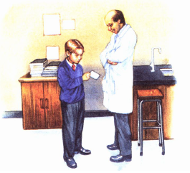
‘Oh, very good, Kevin,’ he said. ‘Part of it like a slug, part like a cockroach, legs like a millipede... What should we call it? A slug-roach-ipede?’
Kevin blinked. He was used to teachers saying weird things that they thought were funny, but he didn’t understand why Mr. Cooper was trying to be funny about the bug.
‘If you made it yourself, you did a good job,’ Mr. Cooper went on. ‘But it’s just a bit too impossible. Or is it supposed to be a model of some alien monster?’

‘No, it’s...’ Kevin began. But then he stopped. He decided not to tell Mr. Cooper about the bug. Not if it was that strange.
Some days later he was sitting quietly with his bug at the side of his house, keeping out of sight.
‘I think you really are from space,’ Kevin told his bug. ‘Maybe I should show you to people at a TV station or something. I could get rich and famous. The Boy who Found the Bug from Another World.’
Then he got up quickly. The bug had started up the side of the house and Kevin didn’t want it to climb out of his reach. But it stopped after a moment and sat still on the sun-warmed brick of the wall. He picked it up and stared for a moment at the wall. Where the bug had been, a small round hole had appeared.
Kevin knew that insects ate many different things. But he had never heard of a bug that ate bricks. Or plaster – since he now had a good idea how it had made those small marks on the wall of his room.
I will be rich and famous, Kevin thought. And he began to dream of appearing on ‘Blue Peter’ with his bug.
He went on daydreaming and the next day he decided to tell his closest friends. Not that he wanted to boast or show off – not really.
But at morning break, he thought he should have just one more trial run. Unseen, he released the bug on to the brick wall of the school boiler room.
It scuttled upwards a little way, then stopped. Its tiny head moved as it began to eat. Grinning to himself, Kevin reached for it.
But perhaps the bug had had its meals interrupted by Kevin once too often. In any case, it scuttled away in an extra-long, high-speed dash that took it up the wall, out of his reach.
There it stopped, while Kevin vainly tried to jump up and grab it. It climbed higher.
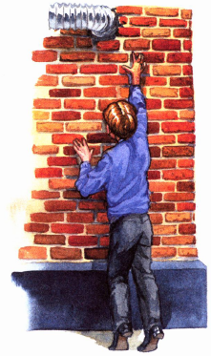
‘No!’ Kevin shouted, not caring if anyone heard. But the bug managed to squeeze into a tiny space between the pipe and bricks.
And then it vanished. Into the wall of the school.
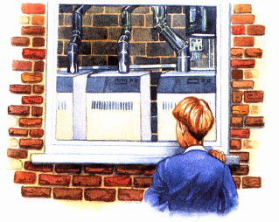
Kevin felt sick and miserable all the rest of that day. After school, and for several days after that, Kevin went back to the boiler room and peered in through the window, looking for the slime trail of his lost bug. It was there, finally, that he saw the sight that made him want to stay away from school.
It wasn’t a slime trail. It was a lot of slime trails. Dozens of them, maybe hundreds, criss-crossing all over the floor and the walls. Along with dozens or hundreds of small smooth holes.
Somehow, Kevin knew the awful truth. The warmth of the boiler had caused his bug to give birth to a lot of smaller bugs. Dozens, maybe hundreds, of baby slug-roach-ipedes. Who might soon themselves grow up and give birth to many more babies. Hungry ones.
No-one would ever be able to catch or kill those small, scuttling, brick-eating bugs. Not even if they found out all about them. The bugs would hide by day in the walls of the school building, and when it was empty after school they would come out, and eat and eat. Until one day there’d be...
No more school.

1. Choose the best word or group of words to fit the passage and put a ring around your choice.
(a) This story begins when Kevin found a metal egg

1 mark
(b) When the egg
1 mark
Kevin found an unusual bug inside it. He kept the bug but didn’t tell anyone about it.
(c) Kevin observed his bug as often as he could and discovered that it ate

1 mark
(d) Before he had a chance to tell his friends about it, the bug
1 mark
2. Why do you think Kevin wanted his friend to think that he had found ten pence (page 4)?
___________________________________________________________________
___________________________________________________________________
___________________________________________________________________
2 marks
3. Why was Kevin almost disappointed when he looked at the bug for the second time (page 4)?
___________________________________________________________________
___________________________________________________________________
___________________________________________________________________
1 mark
4. Kevin showed a photograph of his bug to Mr. Cooper, his science teacher (page 5).
(a) What was the purpose of Kevin’s visit to Mr. Cooper?
______________________________________________________________
1 mark
(b) How did Mr. Cooper react to Kevin’s photograph?
______________________________________________________________
______________________________________________________________
______________________________________________________________
1 mark
5. There are two main points in the story when Kevin could have shared his secret but
decided not to.
When are they?
1. _________________________________________________________________
2. _________________________________________________________________
2 marks
6. Find three clues in the story which show that the bug was extraordinary.
1. _________________________________________________________________
2. _________________________________________________________________
3. _________________________________________________________________
2 marks

7. Kevin’s feelings changed throughout the story.
Draw lines to match each of the events to the word which best describes his feelings at the time.
The first one has been done for you.
Event Kevin’s feelings
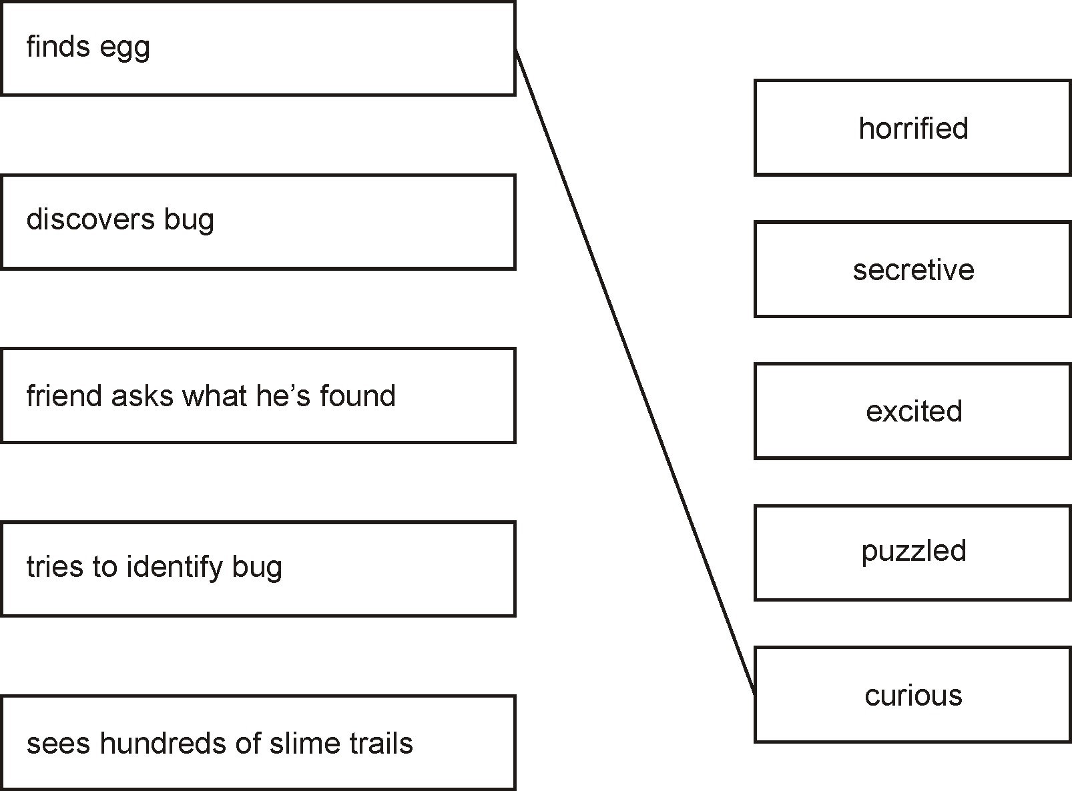
2 marks
8. ...while Kevin vainly tried to jump up and grab it.
Which option most closely matches the meaning of the word vainly?

 | Tick one.
in all directions | 
proudly
quickly
without success
1 mark

9. Kevin could be described as a loner — someone who prefers to be alone.
Do you agree with this description of Kevin?

YES |  | NO
Explain your answer fully, using evidence from the story to help you.

3 marks
10. The end of the story leaves you guessing about what will happen next.
Explain fully what you think might happen.
___________________________________________________________________
___________________________________________________________________
___________________________________________________________________
___________________________________________________________________
___________________________________________________________________
___________________________________________________________________
___________________________________________________________________
3 marks

11. The story No More School? is being considered for inclusion in a new collection of short stories.
Which of the following do you think would be the best title for that collection?

Tick one.
Spooky Stories
Out of this World
Once Upon a Time
An Awfully Big Adventure
Explain why you have chosen this title.
___________________________________________________________________
___________________________________________________________________
___________________________________________________________________
2 marks

