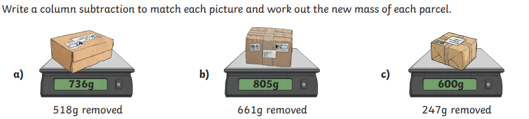
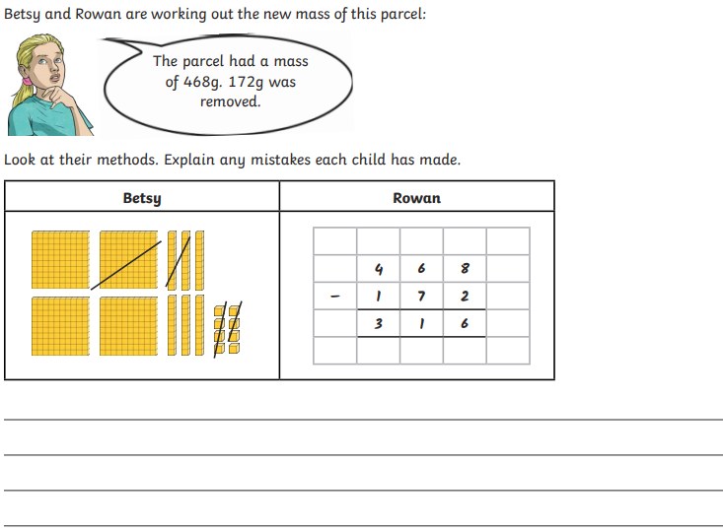
Wednesday 6th January 2021
LO: To add and subtract
C: Subtraction recap

